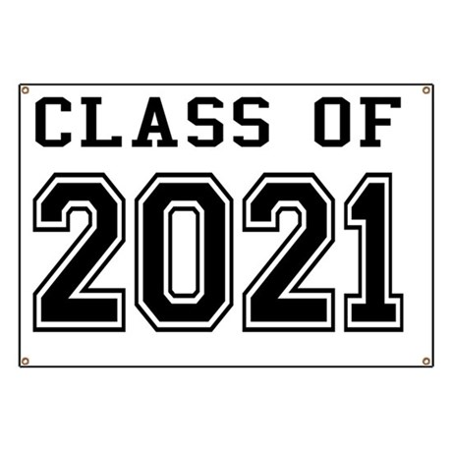

Class of 2021 planning committee will meet on **Monday, February 11, 2019 from 6:30pm - 7:30pm in CMIT South Auditorium**. Students who have been assigned to work with the various committees are strongly encouraged to attend. Parents, if you have not already signed up to be part of the committee, or if you would like to learn more about what is being planned for Class 2021 please join us.

Class 2021 Planning Committee