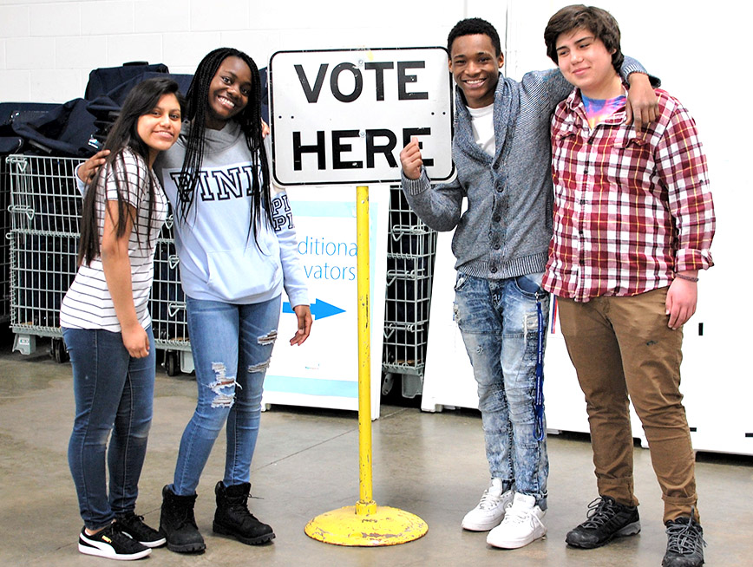  become a STUDENT  ELECTION judge  election day november 8, 2022  Student Election Judges, also known as poll workers in other states, are a vital part of in-person voting. Earn up to 15 community service hours, or $200 compensation. These paid volunteers check in voters, assist voters with disabilities use accessible ballot marking devices, hand out “I voted” stickers, and do many other important jobs to make sure that the polling places run smoothly.  - Must be at least 17 years old.  - Must be able to read, write and follow directions.  - Bilingual students are also needed! (English/Spanish) | Election Day  NOVEMBER 8, 2022  ────  Complete a 3.5- hour long training.  October 22, 2022  1:00 PM – 4:30 PM  ────  Go online to apply  ────  elections.mypgc.us/judge-app  PRINCE GEORGE’S COUNTY BOARD OF ELECTIONS  1100 Mercantile Lane, Ste 115A  Largo, MD 20774  Contact:  Election Judge Recruiter  301-341-7358  