CSP Bulletin: Grade 10
Upcoming Dates:
Quarterly Assessments
English & Social Studies - October 29/30
WCL & Science - November 5/6
Math & Fine Arts - November 9/10
AP Courses - October 22-November 13

Tips for Success | 10 Ways to Help Your Child Succeed in High School  - Attend Parent-Teacher Conferences  - Support Homework Expectations  - Send Your Child to School Ready to Learn  - Instill Organization Skills  - Teach Study Skills  - Know the Disciplinary and Bullying Policies  - Get Involved  - Take Attendance Seriously  - Make Time to Talk About School
10th Grade English  Kaitlyn DiMarco  kdimarco@mycsp.org  Google Voice: (301) 388-5093 | - We are nearing the end of our identity unit and have been working closely to analyze characters, theme, and author’s purpose in the novel Things Fall Apart.  - Students can look forward to their first class Socratic Seminar during the first week of November.  - We will end our unit on identity with a character analysis full-process essay. Students will work on important writing strategies while drafting in class and participating in an editing session. Essays will be due during the beginning of the second quarter.  - Students are encouraged to attend FLEX if they are falling behind, need clarification, or are struggling with the material in class. As always, I am here to support students as much as I can!
10th Grade Government  Mr. Thompson  cthompson@mycsp.org  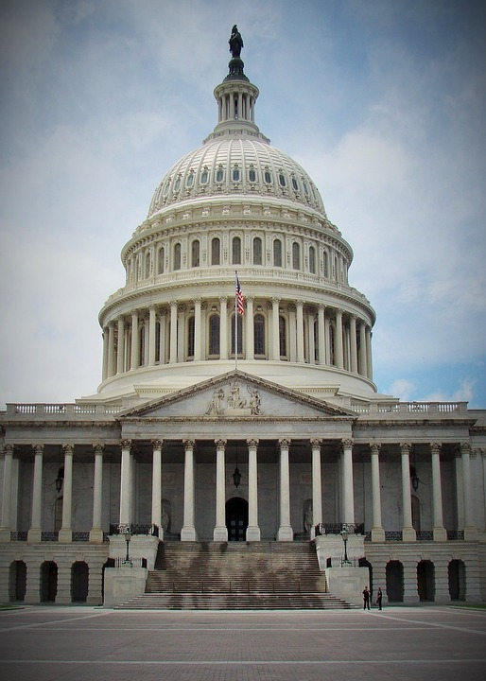  Google Voice: ‪(301) 660-7446‬ | General Updates:  - AP Quarterly’s are Nov. 12 and 13  - Last date for redo assignments is Nov 11  - Most recently, students learned about the legislative branch (AP) and voting behavior. We’ve engaged in great political discussion around the 2020 election!  Synchronous Learning Expectations: In regard to the use of cameras, I am asking that each student turn their camera on when sharing a response. They may feel free to turn the camera off afterwards.  Homework/Projects: Students should have their vocabulary cards and review questions completed. They should not be “Googling” anything. All of the answers can be found from the Topics in Google Classroom. Students, please watch my short videos!  AP Classes: Thank you to everyone for picking up the textbook. If you are still missing one, please contact me as we will be using them in November.  Please sign up for the AP exam by November 6th to avoid a late fee! The sign-up link is below: https://www.familyid.com/chesapeake-science-point-testing/csp-ap-test-registration-2020-2021
Honors Algebra 2  Mrs. Bogador  mbogador@mycsp.org  Flex learning time:  3A Thurs 10:40-11:25  1B Mon 2:55-3:30  2B Wed 9:20-9:45  3B Wed 9:50-10:35  Office Hours  Fri 2:55-3:30  Google Voice:  (301) 660-8629 | Quarterly Assessment Schedule  A Day November 9th  B Day November 10th  Second Quarter starts with an Introduction to Polynomial Functions  Please encourage your student to attend flex learning time for help and complete their assignment on time.  Announcements for new assignments and other important information are posted on google classroom.
10th Grade H Geo  Lyniper Al-os  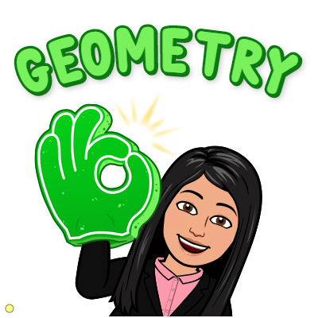  lalos@mycsp.org  Google voice  Office Hour  Friday 2:55-3:30  Meet code: alosofficehour  Weekly eCW is at DeltaMath.com and is always due Every Sunday 8 pm!!  Encourage your Student to join Flex time Office Hour is per invitation only!! | 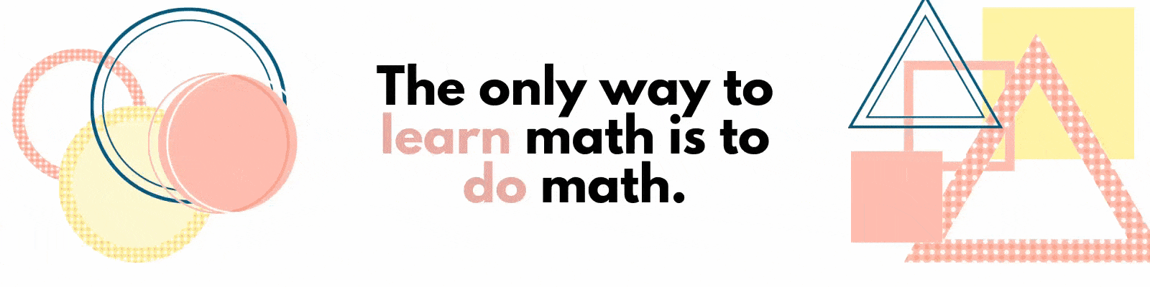  Part 2 of the Geometry in Real life was already posted at the GC. Please encourage your students to complete it at the earliest time possible. The due date will be November 6, 2020.  We are currently working on Slopes of parallel and perpendicular lines and points of concurrency.
Honors Chemistry  George Day  gday@mycsp.org  Google Voice:  (301) 660-6021  Office Hours: Friday 2:55-3:30 | We took our first quiz of the year this week, covering basic atomic structure.  Next we will be talking about electron configurations, orbitals, and valence “shells” next.  I am shifting to a different class format starting next week, where the students will read the material in advance so we can do worksheets and activities in class. I am hopeful that this will give me more time to work with the students in building a better understanding of the content.  As always, I encourage students to utilize FLEX times. This is an outstanding resource made available to the students to get more time to ask specific questions and to clear up misconceptions.
FOSA  Rachel Pratt  rpratt@mycsp.org  https://sites.google.com/mycsp.org/1b-fosa/home | - Students are creating an illustrated interview and utilizing the online platform padlet.  - Please download the padlet app to your mobile device to make uploading work easier.  The app will look like this
American Film Studies  Kristopher Hood  khood@mycsp.org | We are wrapping up the unit on Film History, where we looked at the birth of film. This included the black and white silent films of the 1920’s and the colored “talkies” of the 1930’s and 1940’s. We are analyzing the allegories that can be found in the classic 1939 film, The Wizard of Oz.  We will be starting the Genre Study unit next week. With this unit, students will be asked to view movies of different genres at home. If there is an issue with viewing a movie, please have them reach out to me.
10th Grade Spanish 3  Mrs. Albayrak  Office Hours:  Friday 2:55– 3:30pm  malbayrak@mycsp.org | We have started our unit on sources of information, news, and current events. We will be learning how people from hispanic countries communicate and how their use of media compares to our information consumption in the USA.  We are discussing how technological advances have changed our access to information and what are the advantages and disadvantages.  Students are analyzing information and learning how to be a critical discerner of false news.  Quarterly Assessments will be during week 10.
9-12th Grade  Fitness For Life  Matthew Smith  msmith@mycsp.org  2A- Tues 10:40 - 11:25  4A- Fri 10:40 - 11:25  3B- Wed 10:15 -10:55 | Class Updates:  October- Hypo/Hyperkinetic Conditions  October- Principles of Fitness  Syllabus: https://docs.google.com/document/d/1mir12ZWrsmAkOf5MNt1WdxzAFLWzHDK3OYEfIx6BzHk/edit

