William S. Schmidt Outdoor Education Center Clean Up
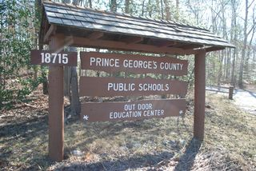

- Where: Meet @ The Schmidt Center, 18715 Aquasco Rd, Brandywine, MD 20613 (Follow signs once on campus)
- When: Saturday, October 27, 2018 from 9:00am to approx. 2:00pm (cleaning ends @ 1:00pm when lunch is provided) // Rain or Shine
- What: Trim trails, weed flower beds, paint markers, trim trees, planting shrubs, etc.
- Who: Adults and Prince George’s Co. students in middle school and above (Great way for students in grades 6-12 to earn Service Learning hours!)
  - Middle school students must be accompanied by an adult
- Please RSVP online at https://www.surveymonkey.com/r/NR76NPZ
- Questions? Call The Schmidt Center at 301-888-1185 or email kathryn.fuller@pgcps.org

William S. Schmidt Outdoor Education Center Clean Up

- Where: Meet @ The Schmidt Center, 18715 Aquasco Rd, Brandywine, MD 20613 (Follow signs once on campus)
- When: Saturday, October 27, 2018 from 9:00am to approx. 2:00pm (cleaning ends @ 1:00pm when lunch is provided) // Rain or Shine
- What: Trim trails, weed flower beds, paint markers, trim trees, planting shrubs, etc.
- Who: Adults and Prince George’s Co. students in middle school and above (Great way for students in grades 6-12 to earn Service Learning hours!)
  - Middle school students must be accompanied by an adult
- Please RSVP online at https://www.surveymonkey.com/r/NR76NPZ
- Questions? Call The Schmidt Center at 301-888-1185 or email kathryn.fuller@pgcps.org

