

William S. Schmidt Outdoor Education Center

Clean Up Event

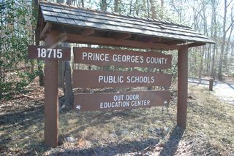

**Service-Learning Opportunity for Students in Grades 6-12!**

*Students participating will earn hours toward the Maryland service-learning requirement*

*for high school graduation.*

**What:** Trimming trails, weeding flower beds, painting markers, trimming trees,

planting shrubs, etc.

**Where:** William S. Schmidt Outdoor Education Center

18715 Aquasco Road

Brandywine, MD 20613

(Follow signs once on campus)

**When:** Saturday, October 19, 2019 at 9:00am - 2:00pm **(Rain or Shine)**

Lunch will be provided at 1:00pm

**Who:** PGCPS middle and high school students and adults.

**Middle school students must be accompanied by an adult.**

**Attire:** Dressfor working in the outdoors with long pants, comfortable shoes, and something

to keep you warm if it is chilly. If you have a pair of work gloves, please bring them.

Expect to get dirty!

Please RSVPonline by accessing the link:  [**https://tinyurl.com/CampSchmidtCleanUp**](https://tinyurl.com/CampSchmidtCleanUp)

For questions, please contact Ms. Kathy Fullerat 301-888-1185 or email [kathryn.fuller@pgcps.org](mailto:kathryn.fuller@pgcps.org)