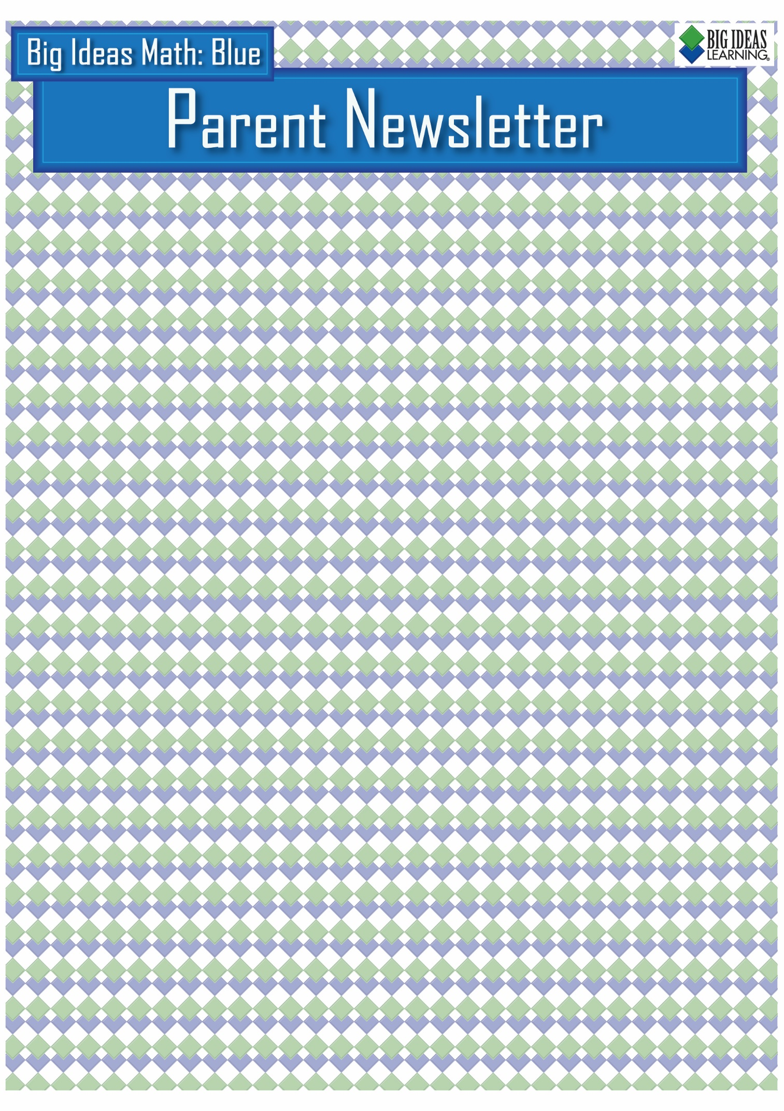

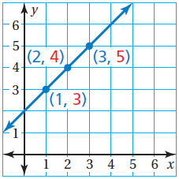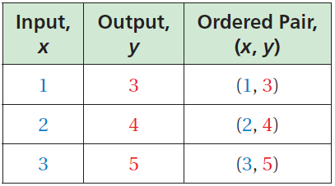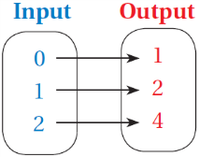

**Key Terms**

Ordered pairs can be used to show ***inputs*** and ***outputs***.

A ***relation*** pairs inputs with outputs. A relation can be represented by ordered pairs or a ***mapping diagram***.

A relation that pairs each input with *exactly one* output is a ***function***.

A ***function rule*** is an equation that describes the relationship between inputs (independent variable) and outputs (dependent variable).

A ***linear function*** is a function whose graph is a nonvertical line.

A ***nonlinear function*** does not have a constant rate of change.

**Standards**

**Common Core:**

**8.F.1:** Understand that a function is a rule that assigns to each input exactly one output. The graph of a function is the set of ordered pairs consisting of an input and the corresponding output.

**8.F.2:** Compare properties of two functions each represented in a different way (algebraically, graphically, numerically in tables, or by verbal descriptions).

**8.F.3:** Interpret the equation *y = mx + b* as defining a linear function, whose graph is a straight line; give examples of functions that are not linear.

**8.F.4:** Construct a function to model a linear relationship between two quantities. Determine the rate of change and initial value of the function from a description of a relationship or from two (*x, y*) values, including reading these from a table or from a graph. Interpret the rate of change and initial value of a linear function in terms of the situation it models, and in terms of its graph or a table of values.

**8.F.5:** Describe qualitatively the functional relationship between two quantities by analyzing a graph (e.g., where the function is increasing or decreasing, linear or nonlinear). Sketch a graph that exhibits the qualitative features of a function that has been described verbally.

**Functions as Tables and Graphs**

A function can be represented by an input-output table and by

a graph. The table and graph below represent the function

*y* = *x* + 2.

By drawing a line through the points, you graph *all* of the solutions of the function *y* = *x* + 2.

**Students will…**

Define relations and functions.

Determine whether relations are functions.

Describe patterns in mapping diagrams.

Write function rules.

Use input-output tables to represent functions.

Use graphs to represent functions.

Understand that the equation

*y* = *mx* + *b* defines a linear function.

Write linear functions using graphs or tables.

Compare linear functions.

Identify linear and nonlinear functions from tables or graphs.

Compare linear and nonlinear functions.

Analyze the relationship between two quantities using graphs.

Sketch graphs to represent the relationship between two quantities.

**Relations and Mapping Diagrams**

***Ordered Pairs Mapping Diagram***

(0, 1)

(1, 2)

(2, 4)

**Chapter 7: Functions**

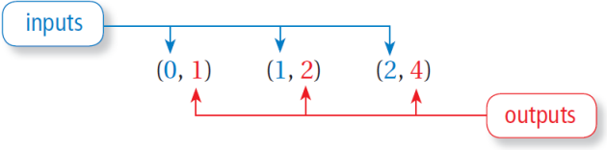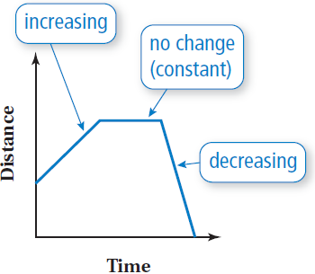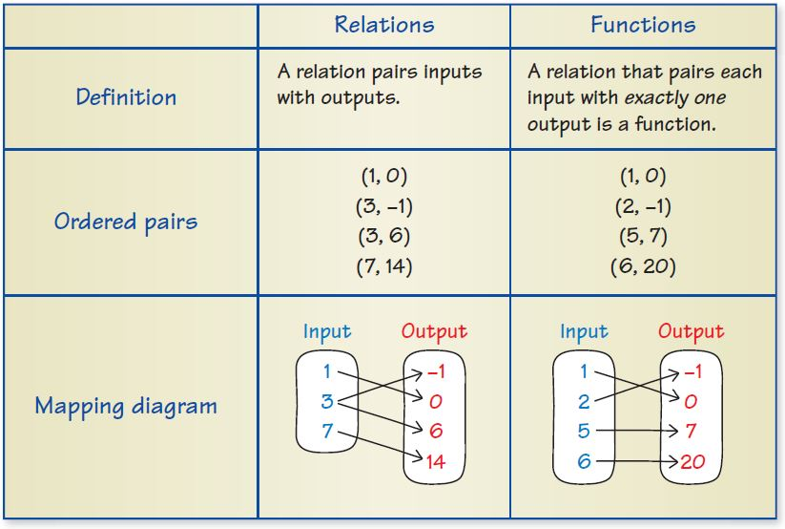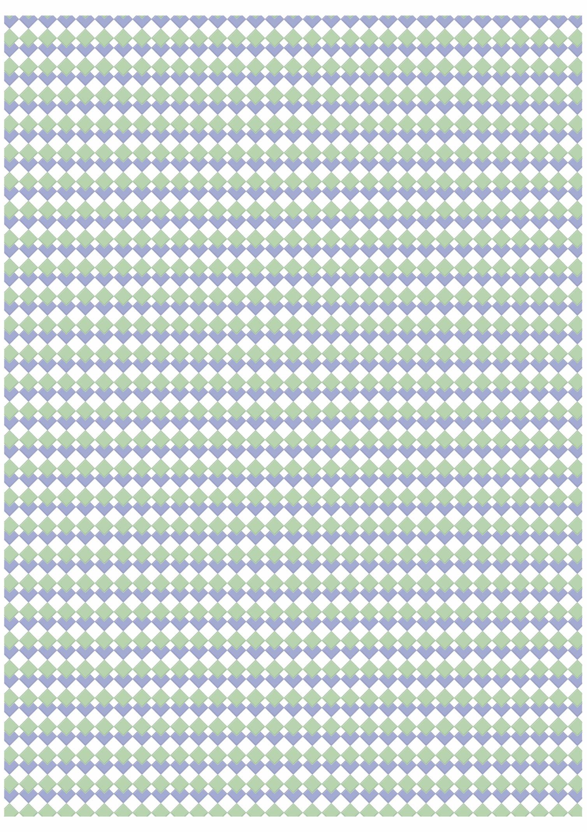

**What’s the Point?**

The ability to recognize and analyze functions is very useful in real life for events like tracking

account balances. Ask your student to track the balance of an account that earns compound interest

and an account that earns simple interest. Which type of account would they set up for themselves?

Why?

The STEM Videos available online show ways to use mathematics in real-life situations.

The Chapter 7 STEAM Video is posted to Google Classroom.

**Quick Review**

* A mapping diagram is one way of showing the result of evaluating an expression or formula for a set of numbers.
* A function can be represented by mapping diagram, ordered pairs, graph, area model, equation, table of values, and words.
* A linear function can be written in the form *y* = *mx* + *b*, where *m* is the slope and *b* is the *y*-intercept.
* The graph of a nonlinear function is *not* a line.
* Graphs can show the relationship between quantities without using specific numbers on the axes.

**Essential Questions**

How can you use a mapping diagram to show the relationship between two data sets?

How can you represent a function in different ways?

How can you use a function to describe a linear pattern?

How can you recognize when a pattern in real life is linear or nonlinear?

How can you use a graph to represent relationships between quantities without using numbers?

**Reference Tools**

A **Comparison Chart** can be used to compare two topics. List different aspects of the two topics in the left column. These can include *algebra,* *definition, description, equation(s),* *graph(s), table(s),* and *words*. Write about or give examples illustrating these aspects in the other two columns for the topics being compared. Comparison charts are particularly useful with topics that are related but that have distinct differences. Your student can place their comparison charts on note cards to use as a quick study reference.