

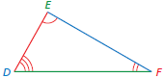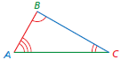

**Essential Questions**

How can you identify congruent triangles?

How can you arrange tiles to make a tessellation?

How can you use reflections to classify a frieze pattern?

What are the three basic ways to move an object in a plane?

How can you use proportions to help make decisions in art, design, and magazine layouts?

How do changes in dimensions of similar geometric figures affect the perimeters and the areas of the figures?

How can you enlarge or reduce a figure in the coordinate plane?

**Similar Figures**

* Figures that have the same shape but not necessarily the same size are called **similar figures**.
* Two figures are similar when
* corresponding side lengths are proportional and
* corresponding angles are congruent.

Triangle *ABC* is similar to Triangle *DEF*.

***Side Lengths Angles Figures***

$\frac{AB}{DE}=\frac{BC}{EF}=\frac{AC}{DF}$ ∠*A* ≅ ∠*D* △*ABC* ∼ △*DEF*

∠*B* ≅ ∠*E*

∠*C* ≅ ∠*F*

**Standards**

**Common Core:**

**8.G.1:** Verify experimentally the properties of rotations, reflections, and translations.

**8.G.2:** Understand that a two-dimensional figure is congruent to another if the second can be obtained from the first by a sequence of rotations, reflections, and translations; given two congruent figures, describe a sequence that exhibits the congruence between them.

**8.G.3:** Describe the effect of dilations, translations, rotations, and reflections on two-dimensional figures using coordinates.

**8.G.4:** Understand that a two-dimensional figure is similar to another if the second can be obtained from the first by a sequence of rotations, reflections, translations, and dilations; given two similar two-dimensional figures, describe a sequence that exhibits the similarity between them.

**Key Terms**

A ***transformation*** changes a figure into another figure.

The new figure formed by a transformation is called the ***image***.

A ***translation*** is a transformation in which a figure slides but does not turn.

A ***reflection***, or *flip*, is a transformation in which a figure is reflected in a line called the line of reflection.

A ***line of reflection*** is a line that a figure is reflected in to create a mirror image of the original figure.

A ***dilation*** is a transformation in which a figure is made larger or smaller with respect to a point called the center of dilation.

A point with respect to which a figure is dilated is called the ***center of dilation***.

The ratio of the side lengths of the image to the corresponding side lengths of the original figure is the ***scale factor*** of the dilation.

**Students will…**

Name corresponding angles and corresponding sides of congruent figures.

Identify congruent figures.

Identify translations.

Translate figures in the coordinate plane.

Identify reflections.

Reflect figures in the *x*-axis or the *y*-axis of the coordinate plane.

Identify rotations.

Rotate figures in the coordinate plane.

Use more than one transformation to find images of figures.

Name corresponding angles and corresponding sides of similar figures.

Identify similar figures.

Find unknown measures of similar figures.

Understand the relationship between perimeters of similar figures.

Understand the relationship between areas of similar figures.

Find ratios of perimeters and areas for similar figures.

Dilate figures in the coordinate plane.

Use more than one transformation to find images of figures.

Identify dilations.

**Chapter 2: Transformations**

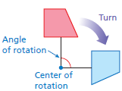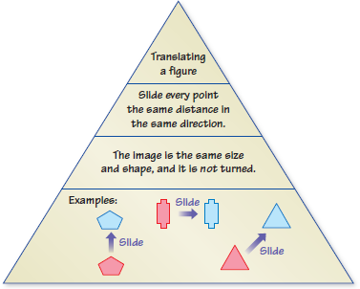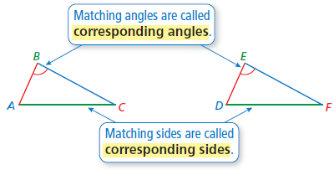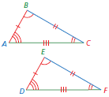

* In a rotation, the original figure and its image are congruent.

**Rotations**

* A **rotation**, or *turn*, is a transformation in which a figure is rotated about a point called the **center of rotation**.
* The number of degrees a figure rotates is the **angle** **of rotation**.

**Quick Review**

* In a translation, every point of the figure moves the same distance and in the same direction.
* A reflection creates a mirror image of the original figure.
* The symbol ∼ means *is similar to*.
* The symbol ≅ means *is congruent to*.
* The image of a translation, reflection, or rotation is congruent to the original figure, and the image of a dilation is similar to the original figure.
* Two figures are similar when one can be obtained from the other by a sequence of translations, reflections, rotations, and dilations.

**What’s the Point?**

The ability to use transformations is very useful in real life when building scale models. Scale models are used by engineers to design many different things. Have your student create a scale model of something with toothpicks, clay, or paper. What kind of transformation does this represent?

The STEM Videos available online show

ways to use mathematics in real-life

situations. The Chapter 2: Shadow Puppets

STEM Video will be available on Google Clssroom. ne at

www.bigideasmath.com.

**Reference Tools**

A **Summary Triangle** can be used to explain a concept. Typically, the summary triangle is divided into 3 or 4 parts. In the top part, write the concept being explained. In the middle part(s), write any procedure, explanation, description, definition, theorem, and/or formula(s). In the bottom part, write an example to illustrate the concept. Place summary triangles on note cards to use as a quick study reference.

**Perimeters of Similar Figures**

When two figures are similar, the ratio of their perimeters is equal to the ratio of their corresponding side lengths.

**Areas of Similar Figures**

When two figures are similar, the ratio of their areas is equal to the *square* of the ratio of their corresponding side lengths.

**Dilations in the Coordinate Plane**

* To dilate a figure with respect to the origin, multiply the coordinates of each vertex by the scale factor *k*.
* (*x*, *y*) →(*kx*, *ky*)
* When *k* > 1, the dilation is an enlargement.
* When *k* > 0 and *k* < 1, the dilation is a reduction.

**Translations in the Coordinate Plane**

* To translate a figure *a* units horizontally and *b* units vertically in a coordinate plane, add *a* to the *x*-coordinates and *b* to the *y*-coordinates of the vertices. Positive values of *a* and *b* represent translations up and right. Negative values of *a* and *b* represent translations down and left.
* (*x*, *y*) → (*x* + *a*, *y* + *b*)
* In a translation, the original figure and its image are congruent.

**Reflections in the Coordinate Plane**

* To reflect a figure in the *x*-axis, take the opposite of the *y*-coordinate. To reflect a figure in the *y*-axis, take the opposite of the *x*-coordinate.
* Reflection in *x*-axis: (*x*, *y*) → (*x*, − *y*)

Reflection in *y*-axis: (*x*, *y*) → (− *x*, *y*)

* In a reflection, the original figure and its image are congruent.

**Identifying Congruent Figures**

Two figures are congruent when corresponding angles and corresponding sides are congruent.

Triangle *ABC* is congruent to

Triangle *DEF*.

△*ABC* ≅ △*DEF*

**Congruent Figures**

Figures that have the same size and the same shape are called **congruent figures**. The triangles below are congruent.