***Name ___________________________ Date_______________***

**Quarter 1 Culminating Task**

**Human Intelligence Podcast**

During this quarter you have read a variety of print and non-print texts about human intelligence. For example, you learned about Howard Gardner’s 9 types of Intelligence in different articles we read on SavvasRealize. Now, imagine that a media production company is seeking student-created podcasts that will inform their audience about those topics mentioned below related to human intelligence.

Select one of the nine aspects of human intelligence mentioned below that interests you and create a 2-5 minutes podcast. Since the topic of human intelligence is so broad, you will need to select one specific issue or idea to focus on. Once you have narrowed down your topic, use an outline to plan out the format of your podcast which might include interviews, storytelling, multi-host discussions, and/or host commentary on the topic. Be sure that your podcast includes audio elements such as audio clips, sound effects, background music, and/or transitional sounds.

**Active Reading: Unlocking a Prompt Steps:**

1. Read the prompt/task carefully.

2. Circle the key direction verbs and underline important ideas.

3. Explain what the prompt is asking you to do in your own words.

4. Restate the prompt expectations and develop your plan for this task.

**QUARTER 1 CULMINATING TASK RUBRIC: 100 POINTS**

1. **Select a Human Intelligence Topic: (10 Points)**

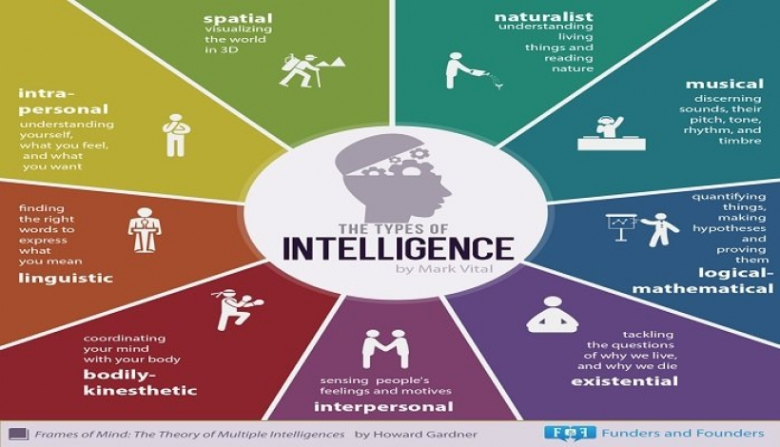

1. **Podcast Format Outline: Select one of the following formats: (25 Points)**
2. Interviews
3. Story-telling
4. Multi-host discussion/commentary
5. Research the topic of your choice and create an outline. Upload to Edmodo.
6. **Podcast content: A 2-5 min interview, story, or discussion (25 Points)**
7. You may create a voice recording of your interview, story, or discussion on your phone or computer. You must save the recording in your Google Drive, copy the link, and **post the link on Edmodo.com in the correct assignment link.**
8. You may work in groups of a maximum of four students.
9. Every student must state their name on the Podcast and every student’s voice must be heard during the interview or discussion to receive credit.
10. Each student in the group must upload the Podcast link (voice recording) on Edmodo in order to receive credit.
11. **Audio Elements: (40 Points)**
12. Audio Clips (10 pts.)
13. Sound Effects (10 pts.)
14. Background music (10 pts.)
15. Transitional Sounds (10 pts.