**CMIT North MS**

**STEAM FAIR TIMELINE 2022-2023**

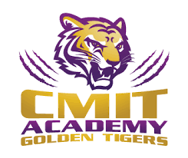

| **STEAM Fair Packet Distribution** | **Friday, October 21,**  **2022** |
| --- | --- |
| **STEAM Fair Proposal Due** | **Tuesday, November 1, 2022** |
| **STEAM Fair Feedback to Students** | **Wednesday, November 9, 2022** |
| **STEAM Fair Research Papers submitted to science teachers** | **Monday, November 28,**  **2022** |
| **STEAM Fair Research Paper Feedback** | **Wednesday, December 7,**  **2022** |
| **Students submit and present STEAM Fair Projects in class** | **Monday, December 12, 2022** |
| **Students Selected for STEAM Fair**   * **Science Department will meet and go through their STEAM Fair rubrics** * **Top projects in each category will be chosen to go to CMIT STEAM Fair** | **Tuesday**  **January 10, 2023** |
| **Students and parents notified of their invitation to compete in the CMIT STEAM Fair** | **Tuesday, January 10,**  **2023** |
| **CMIT STEAM Fair** | **Saturday, January 28,**  **2023** |