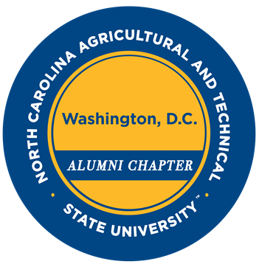

The Washington, DC Alumni Chapter of North Carolina Agricultural and Technical State University

Scholarship Application - Spring 2022

Our 2022 Scholarship Application is now available.    
  
We invite all students from the Washington, DC Metropolitan area of District of Columbia; Maryland Counties: Anne Arundel County, Calvert County, Charles County, Frederick County, Montgomery County, Prince George's County and St. Mary’s County.

Virginia Cities and Counties: Arlington County, City of Alexandria, Clarke County, Culpeper County, Fairfax County, City of Fairfax and the City of Falls Church) to apply for the Washington, DC Chapter Alumni Scholarship.

Please review the scholarship eligibility requirements on the application by clicking the link below.  **Scholarship applications due March 19, 2022**.

[2022 WDC Alumni Chapter, NC A&T SU Scholarship Application](https://forms.gle/hZVZrJQHMrnTJXqUA)

With Aggie Pride,

Andrea E. Hall ‘91

Scholarship Committee Chair 2021-2022

Financial Secretary 2021-2023

WDC Alumni Chapter, NCA&TSU

Celebrating 75 years of Aggie Pride!

*Support the NC A&T Alumni Association when you shop Amazon!*

[*https://smile.amazon.com/ch/23-7055330*](https://smile.amazon.com/ch/23-7055330)