**Winter Break Package**

**Instructions for the Winter Break Project**

Please be reminded that the 3.8 paragraph portion of the package is Mandatory. The other two portions of the package (identifying the author of the quotes and public speech) is optional and for extra credit. We will assign these portions (2nd & 3rd portions) later on when you come back after winter break so keep the package with you. The package is an individual work and no package will be accepted via Edmodo or e-mail. In addition to this, no late work will be accepted even if it is extra credit. The following information gives the instructions.

1. **3.8 Paragraph (Mandatory)**

There will be two separate 3.8 paragraphs in total. You will respond to each question separately in one 3.8 paragraph format. 3.8 paragraph means that you have to include one topic sentence, 3 supporting points and one conclusion sentence in one paragraph and one paragraph has to have 8 sentences in total. You have to bring the hard copy of the paper right after the winter break. Please pay close attention to the project requirements and the 3.8 Paragraph Format Rubric.

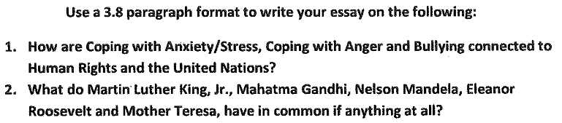

Please see the explanation of the 3.8 Paragraph Model in the next page.

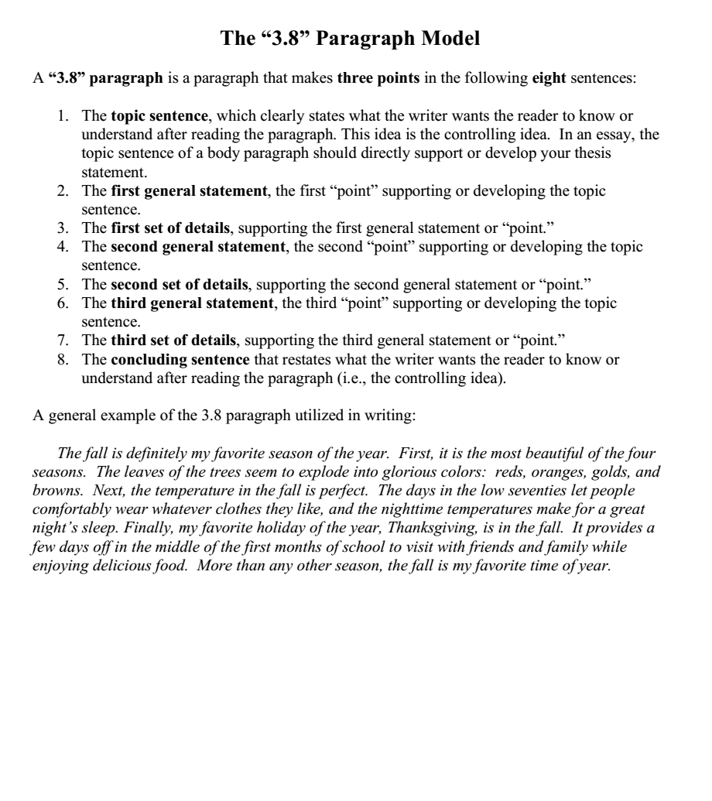

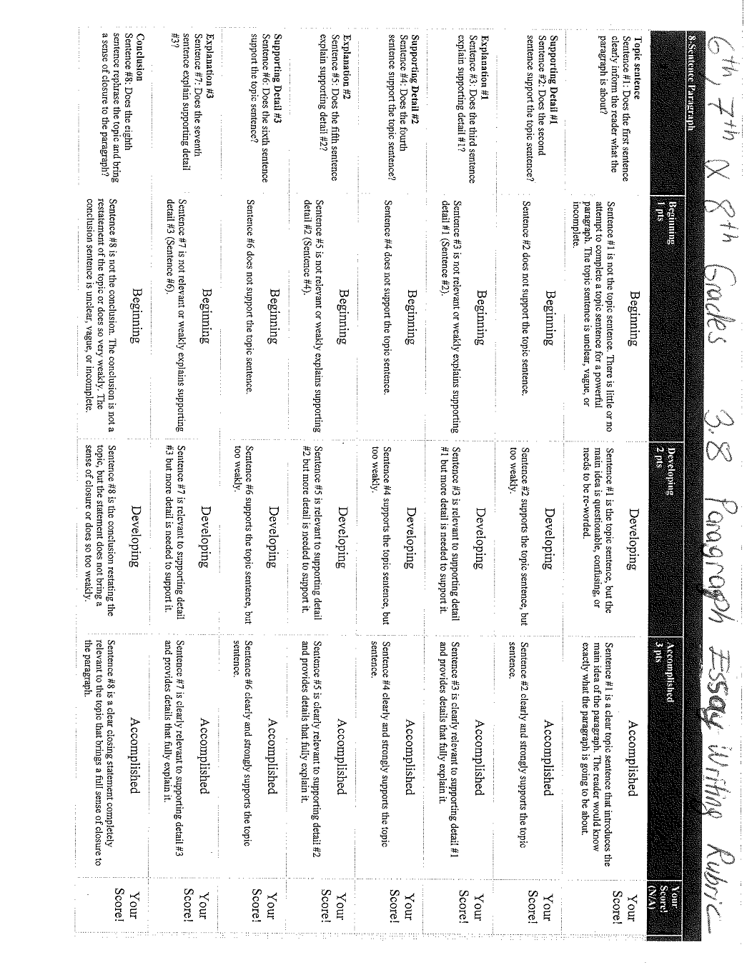

1. **Identifying the author of the famous quotes**  (optional)

In this portion, you need to find the author of the quotes which are provided in the attached documents. You have to bring the hard copy of your paper which includes the quotes and the authors in order to get extra credit.

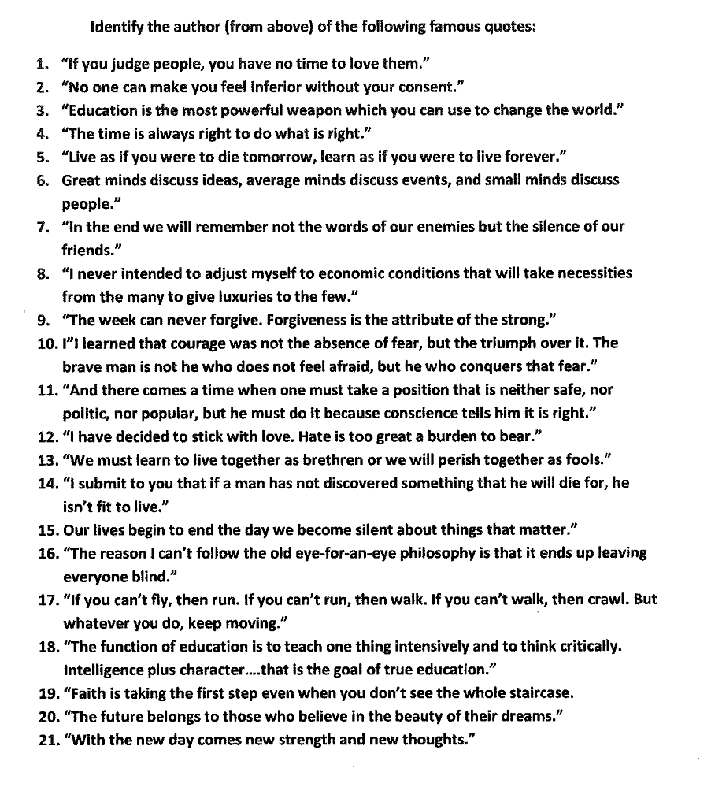

1. **Public Speaking** (optional)

Your speech will be on the things that you mentioned in your 3.8 paragraphs and it will be presented in front of the class when you return back to class after Winter Break in order to get extra credits. Your speech has to be 3 minutes long. Please Pay close attention to the Public Speaking Rubric.

**All of these 3 tasks will be presented right after Winter Break.**

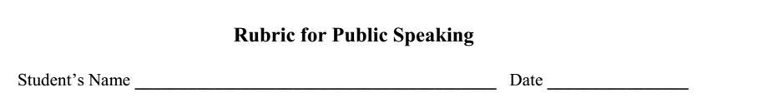

College Name & Number: Total Points:

