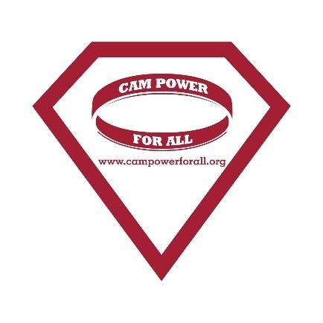

The Cameron Diamond Scholarship Fund
(Deadline: Application Entry MUST be submitted or postmarked on or by March 15th)
Overview
We are pleased to announce the 3rd Annual Cameron Diamond Scholarship. The winner will be receiving a $1000 scholarship towards the start of a medically related career. The two (2) runners up will receive a $500 scholarship.
Cameron, born in 2000, was diagnosed with Leukemia at six weeks of age. Through the wonder of a bone marrow transplant and subsequent recovery, she was pronounced cancer free at age five. Her life however, frequently faced complications because of what her little body endured at such a young age. At 7 years old, she was followed by six different medical teams at Johns Hopkins Children Center. At age 8, in St Louis awaiting a double lung transplant, the world lost a beautiful, courageous, and tough little girl. Her humor, love for life, and fight were an inspiration to her family, friends and many in the community. The assistance from those passionate nurses, practitioners, and therapists helped our family throughout the most difficult time in our lives and we are so excited to encourage a younger generation to be that light in the dark for other families.
Qualifications
To qualify for this scholarship, the applicant must meet ALL of the following criteria:
- Must be a current resident of the state of Maryland;
- Must be an Anne Arundel County High School senior in the graduating class of 2021 and currently planning to attend an accredited post-secondary school (college, university, trade school, or medical school);
- Must be planning to enter a medical or medical-related field. Medical or medical-related field is defined as the professional work of a duly licensed medical practitioner; this includes, but is not limited to nurses, laboratory scientists, pharmacists, physiotherapists, speech therapists, occupational therapists, dietitians, and bioengineers. This does not include administrative services such as secretarial or sales careers.
How to Apply
1) Complete the Scholarship application form that follows.
2) Write a one-page essay (no more than 500 words) on the topic provided. This may be typed or handwritten.
3) The application form and essay must be submitted by March 15, 2021
Applications and Essays can be scanned and sent via e-mail. Please email to: scholarship@campowerforall.org. Please use “Scholarship Application” as the subject.
If mailing, please use the following address:
The Cameron Diamond Scholarship Fund
1439 Crofton Parkway
Crofton, Maryland, 21114

Addition details
- The winner will be decided by a committee of CamPowerForAll (CPFA) Board members, based on the applicant’s meeting of scholarship eligibility and the strength of the written essay.

- The scholarship MUST be used on valid school-related expenses. These include, but are not limited to, tuition, fees, books, or supplies. The student MUST provide proof of attendance at an accredited post-secondary.

- If, for any reason, the winner is deemed to be ineligible for the scholarship, for reasons that include, but are not limited to –failure to attend an accredited post-secondary institution, not meeting the eligibility requirements for the scholarship, or misrepresentation of intended major or career plans – CPFA will have the rights to revoke the scholarship and any monies paid must be returned to the scholarship fund immediately.

- If you have any questions regarding eligibility or the application process, e-mail: scholarship@campowerforall.org

Essay:
In a separate attachment, write a one-page essay (500 words or less) on your goals and aspirations as they relate to your education, career, and future plans. Explain why you are a qualified candidate and should be considered for the scholarship. Please remember that proper grammar and spelling are part of the judging process. IMPORTANT: This essay is a key component in how the committee will pick a winner. Please do your best to include relevant and compelling experiences. Good Luck!

The Cameron Diamond Memorial Scholarship Fund
(Complete All Information)

Contact Information

Name: _______________________________________________________________________
Current Address: _______________________________________________________________
City: ______________________________ State: _________________ Zip: ________
Telephone: ________________________ Email: ________________________________

Academic Information
Intended College or Institution: ___________________________________________________
Major / Track: _________________________________________________________________
Do you intend on pursuing a career in the medical field? Yes: _________ No: ________
In what capacity would you like to work? ____________________________________________

I hereby affirm that all the information provided is true and any false statement will forfeit my qualification for the consideration and awarding of the scholarship. This application is the sole property of The Cameron Diamond Scholarship Fund. All information is strictly confidential and will not be returned.

Signature: ____________________________________________ Date: ______________
Printed Name: __________________________________________________________________
The Cameron Diamond Scholarship Fund encourages all qualified applicants. .The Fund does not discriminate on the basis of race, ethnicity, religion, physical ability, class, sexual orientation, age, sex or gender.

