Na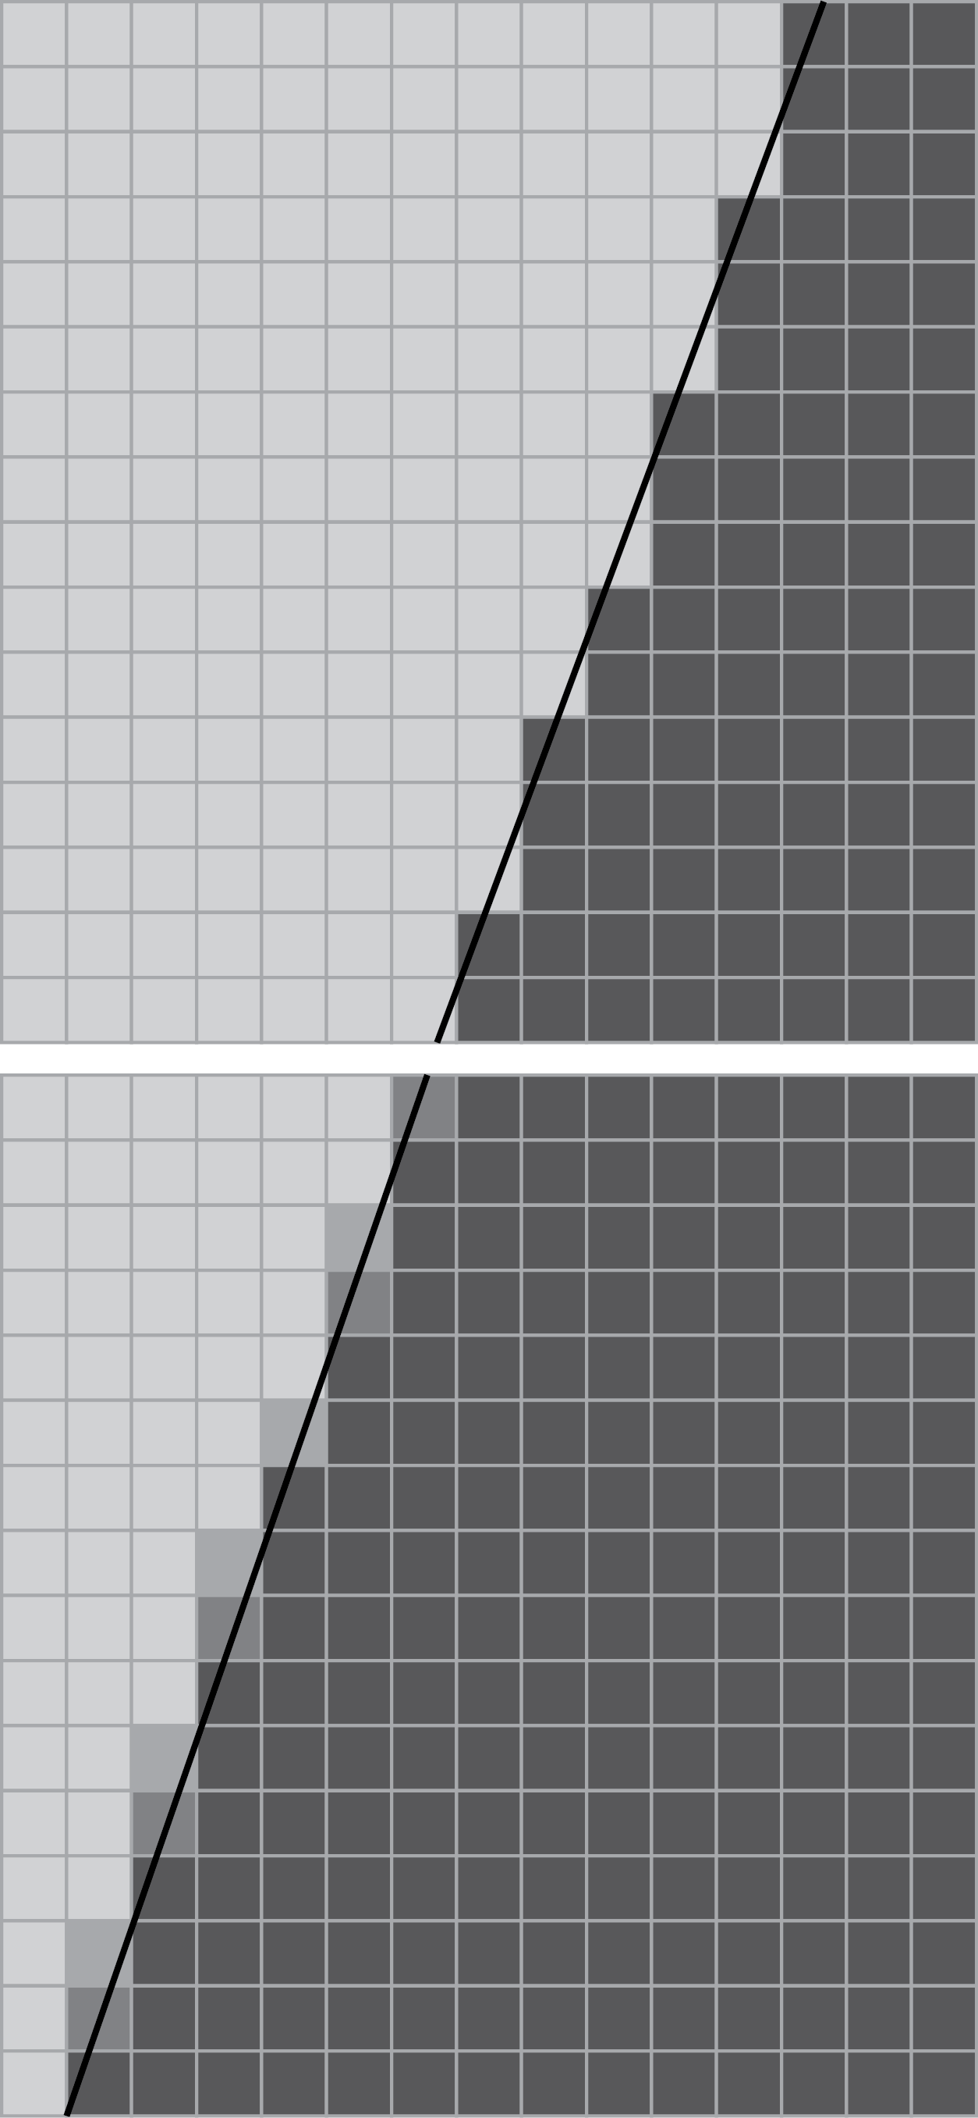me

Dear Family,

Many people enjoy putting their photos on their computers and sharing them online with friends and family. Sometimes, when sharing a photo online, you can see jagged edges that don’t appear in the actual photo. These jagged edges happen because digital photos are actually created by a grid of colored dots.

The colors in the world we see are an example of a continuous range—any number of colors can exist. However, the colors in our camera are an example of a discrete range—a limited number of colors can exist.

When an edge passes through a dot, the camera has   
to decide whether to choose the color on one side   
of the edge or the other. Over a long edge, this can   
lead to a jagged look as the camera chooses one   
color or the other.

You and your student can model this using graph   
paper. Draw a slanted line on the graph paper.   
Color the blocks on one side of the line with red   
and the other side with blue. Choose one color   
or the other for blocks that the line passes through.

* Do you see a jagged pattern?
* What if you change the angle of the line—is   
  the line *more jagged* or *less jagged*?
* What happens if you draw the line using   
  blocks? Does the line look straight or jagged?

To see this, it might help to stand some distance   
away from the paper so the blocks appear smaller.

Modern computer applications try to eliminate the   
jagged edges by blending the colors on each side   
of the line. Try this with your student on a piece of   
graph paper. Does it improve the appearance of the line—especially from a distance?

Take a picture of your project and share it!

Functions

Chapter

7

|  |  |  |
| --- | --- | --- |
| **Lesson** | **Learning Target** | **Success Criteria** |
| 7.1 Relations and Functions | Understand the concept of a function. | * I can represent a relation as a set of ordered pairs. * I can determine whether a relation is a function. * I can use functions to solve real-life problems. |
| 7.2 Representation of Functions | Represent functions in a variety of ways. | * I can write a function rule that describes a relationship. * I can evaluate functions for given inputs. * I can represent functions using tables and graphs. |
| 7.3 Linear Functions | Use functions to model linear relationships. | * I can write linear functions to model relationships. * I can interpret linear functions in real-life situations. |
| 7.4 Comparing Linear and Nonlinear Functions | Understand differences between linear and nonlinear functions. | * I can recognize linear functions represented as tables, equations, and graphs. * I can compare linear and nonlinear functions. |
| 7.5 Analyzing and Sketching Graphs | Use graphs of functions to describe relationships between quantities. | * I can describe relationships between quantities in graphs. * I can sketch graphs given verbal descriptions of relationships. |

Chapter

7

Functions (continued)