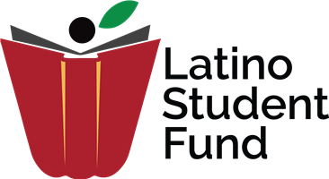

**Maryland Tutoring Program Volunteer Needs**

Since 1998 the Latino Student Fund's Tutoring Program provides free support and academic assistance to Washington metropolitan area students to ensure their academic success. We offer breakfast and individualized tutoring to support students from PreK through 12th grade in math and reading.

We look for volunteers ages 16 and up interested in working one-on-one with students on Saturday mornings from 9:30 to 12pm in Riverdale, MD. LSF staff provides lesson plans and guidance, so all tutors have to bring is enthusiasm and dedication. We have permanent tutors, assigned to a student and expected to come every week, and floaters who we call on only when we need extra tutors (which is most weeks).

To get involved for fall, volunteers would be required to come for a tutor training in late August. Please contact tutoringpgc@latinostudentfund.org for more information, or sign up to be a volunteer at latinostudentfund.volunteerhub.com.