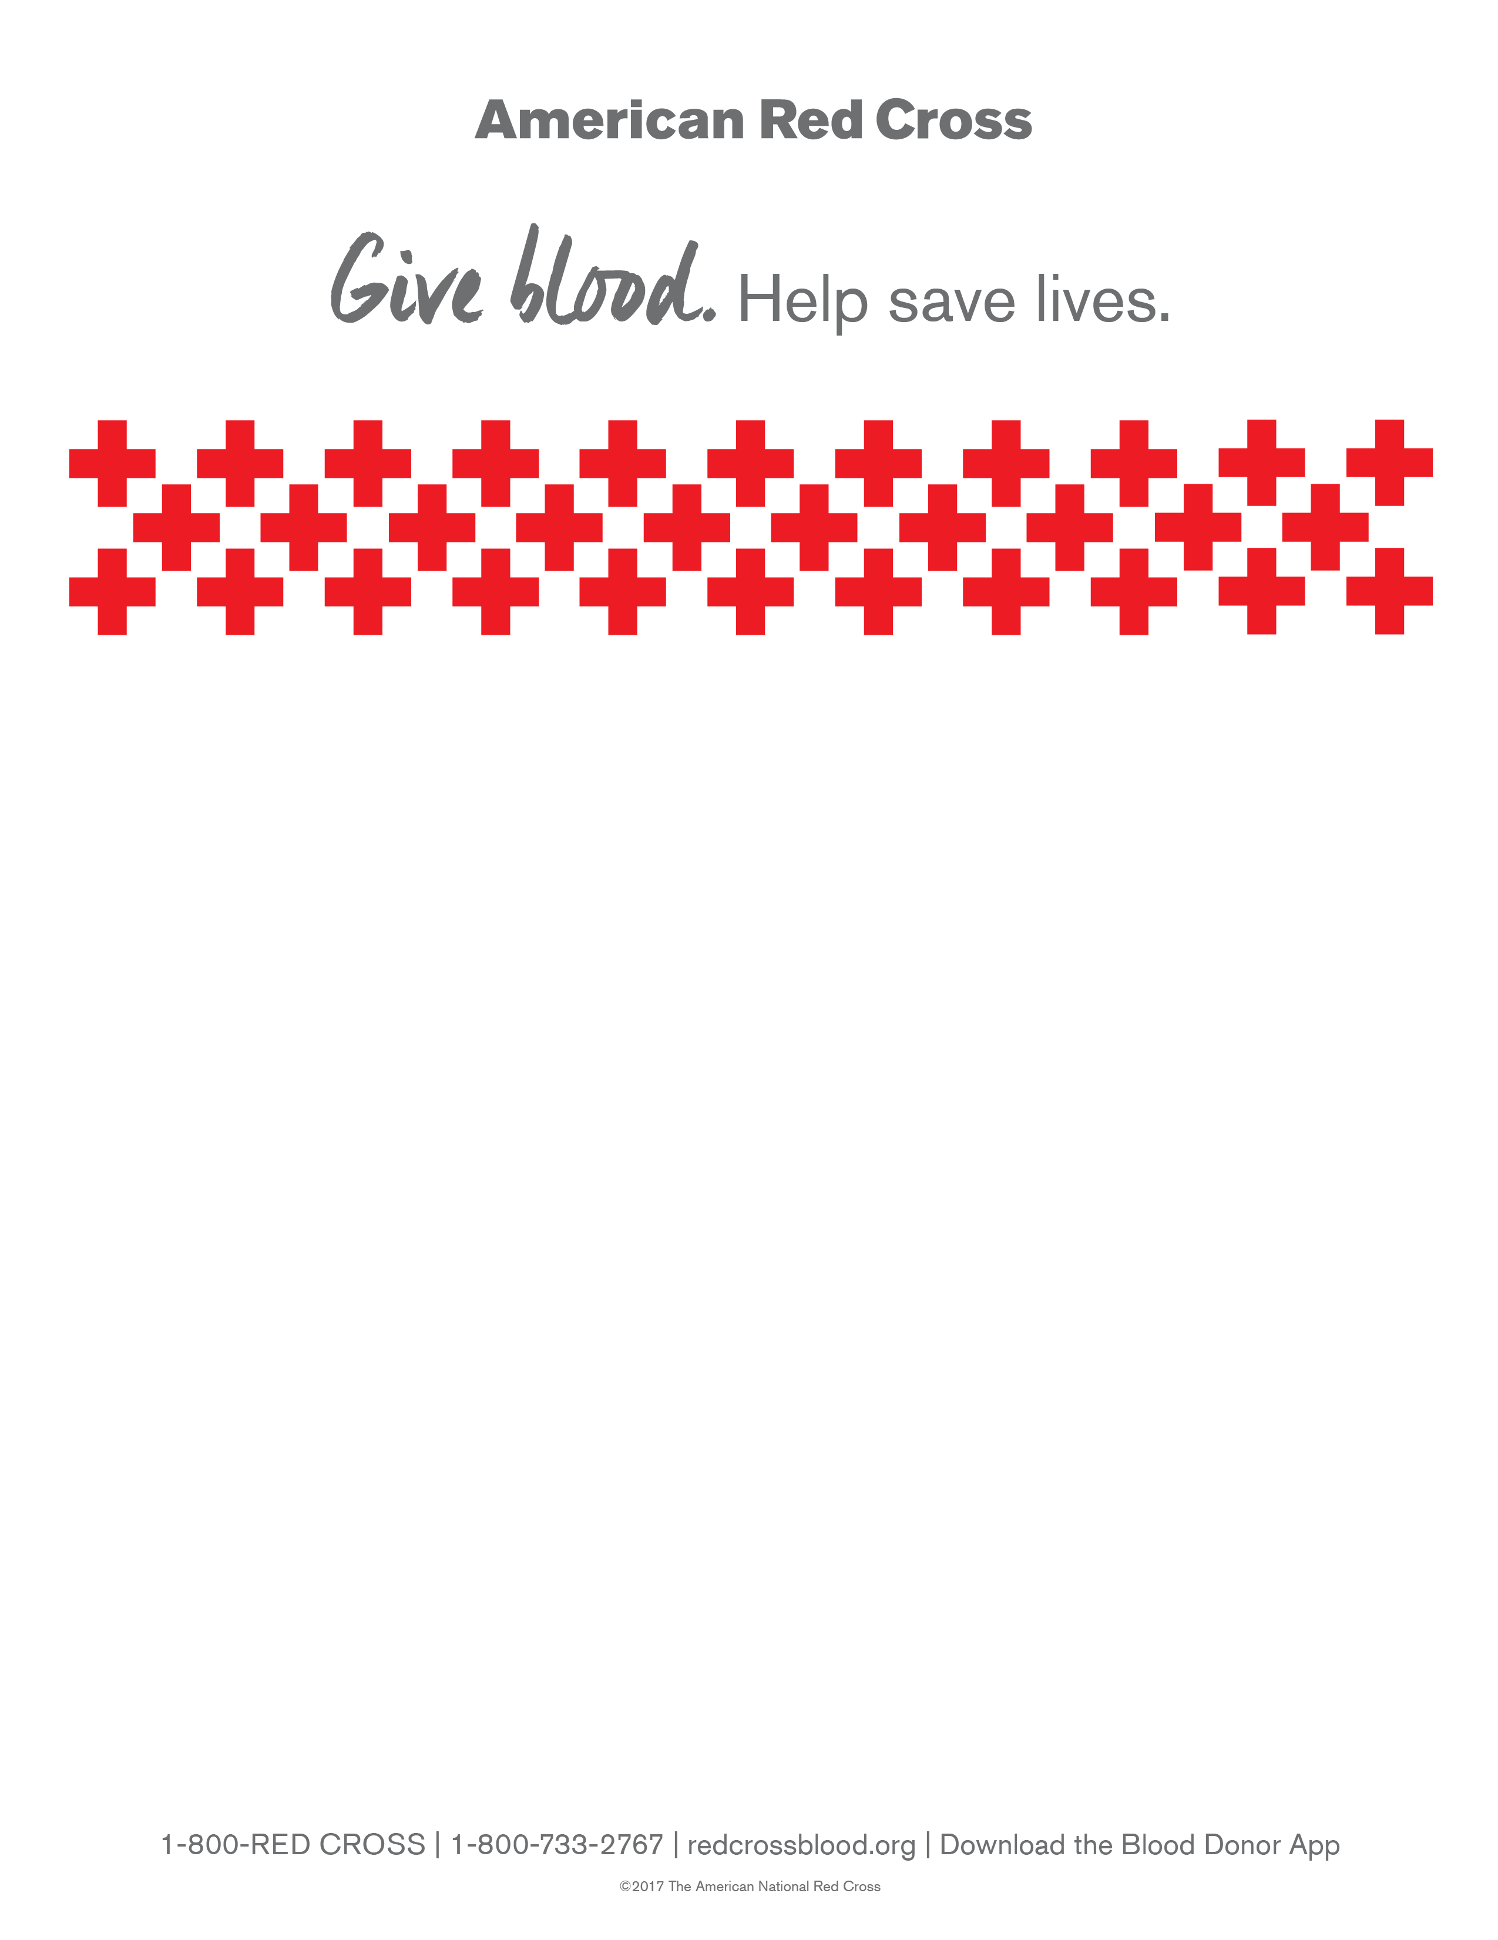

**Chesapeake Science Point Community Blood Drive**

**Thursday, November 29, 2018**

**10:30 a.m.-4:00 p.m.**

**Bloodmobile**

**7321 Parkway Drive**

**Hanover, MD 21076**

**ALL DONORS WILL RECEIVE RED CROSS T-SHIRTS AND PRIZES WILL BE GIVEN!**

**To schedule your lifesaving donation visit redcrossblood.org and enter Sponsor Code: chesapeakesciencepoint**

**Or contact Ms. Bulisco at 443-757-5277 or lbulisco@mycsp.org**