At Home Family Field Day
Spring 2020

Dear CSP Families,

Field day is an important tradition at any school. It is a significant day for students and staff, and we feel that in these incredibly challenging times, Field Day is an event that can unite us and give us positive memories . Even though we will not be having a Field Day at CSP this year, here is a voluntary Field Day that you can do at home for fun!

In this packet, you will find: Field Day Directions, Field Day equipment list, Field Day score card, and an Event description list with directions on how to set-up and play each activity.

All Field Day events are designed to be played indoors or outdoors in a safe space using household items. You do not have to purchase any specialized equipment or supplies. If you don’t have equipment for a specific event, use an alternative or substitute or simply skip that activity. Simply read through the pages below with directions, but feel free to be creative to make each event more challenging!

I hope you and your families enjoy this special event together. On behalf of all CSP staff members, we miss our students, and hope our CSP families stay safe and healthy!

Mr. Smith, P.E. and Health Teacher
GO TIGERS!!!

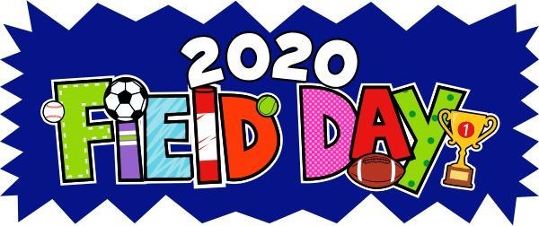

Directions

- If possible, print out this packet. Although you don’t have to print out this packet, you may want to as it may make it easier for you and your family to participate.

- Print a score card, or create your own scorecard, for each participant so you can keep track of each person’s scores.

- Go through the equipment list and gather as much equipment as possible. Remember to be creative when figuring out which supplies may work for an event.

- All participants should read the directions for each event to understand the rules and guidelines in completing each event. Mark off the event set up, prepare a timer, and get ready!

- Record each attempt on the players scorecard. To ensure fairness, THERE IS NO PRACTICING! Each player gets 3 attempts, and should try to improve their score on each attempt. You may practice as many times as you would like AFTER results are noted on scorecard.

- Take video and pictures of participants completing the events. This will provide video replay for questionable calls, and feel free to post and share with friends.

- Decide who wins each event, play again in teams, or just play for fun!

Equipment List

6 Large Socks (to create sock balls)
1 Laundry Basket (or bucket)
6 Medium to Large Plastic Bowls
Paper (to keep tally points)
Pencil or Pen
6’ Ladder
1 Empty Water Bottle
Oversized T-Shirt, Shorts, and a Hat
10 Plastic Cups
Clock or Stopwatch
- Coin
- Paper Plates (or cardboard to use as a fan)
- Balloons
1 Ping Pong Ball (can use a small balloon)
10 Clothing Items
1 Kitchen Spatula
1 Plastic Container Lid
5 to 10 Pairs of Shoes
- 1-Gallon Milk Jugs
- to 6 Sheets of Paper (for making airplanes)
1 Medium-sized Bucket
1 Plastic (Tupperware) Container
1 Spoon
1 Small Object that Fits in Spoon

Scorecard

Participant Name: _______________________________________________________
Event | #1 | #2 | #3
Backboard Bank It
Bowl Ball
Climb the Ladder
Clothes Relay
Coin Flip 400-Meter Dash
Fan-A-War
Fast Folder
Flip Your Lid
If the Shoe Fits
Keep It Up
Milk Jug Relay
Paper Plane Corn Hole
Penguin Race
Spoon Relay
Sock-er Skee-Ball
Tennis Shoe Tower
Water Bottle Trap
Wind Bowling

Get Ready: 5+ Large Sock Balls, Laundry Basket or Bucket, A Wall​

Get Set: Roll up the socks to make sock-balls. Place the basket or​ bucket against the wall. Mark a distance 5’ – 10’ from the basket.

GO!
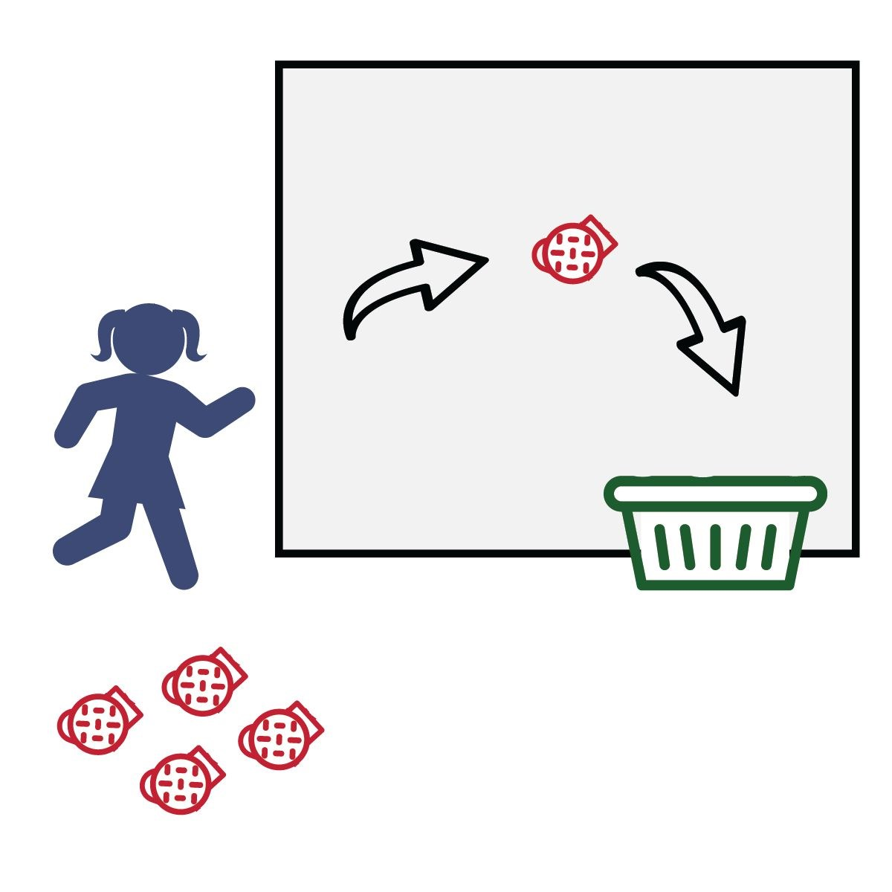
- This event is called Backboard Bank
It.
- The object of this game is to score as many points as you can in 1 minute.
- Do that by tossing the sock balls off of the wall and into the basket. You MUST use the wall as your backboard and bank it into the basket.
- Score a point for every sock that is banked into the basket.
● Write your score down on the official Field Day Score Card.

Get Ready: 1 Coin​

Get Set: Find an open space with enough room to run in place​ safely.
Hold the coin in your hand – be ready to flip it.

GO!
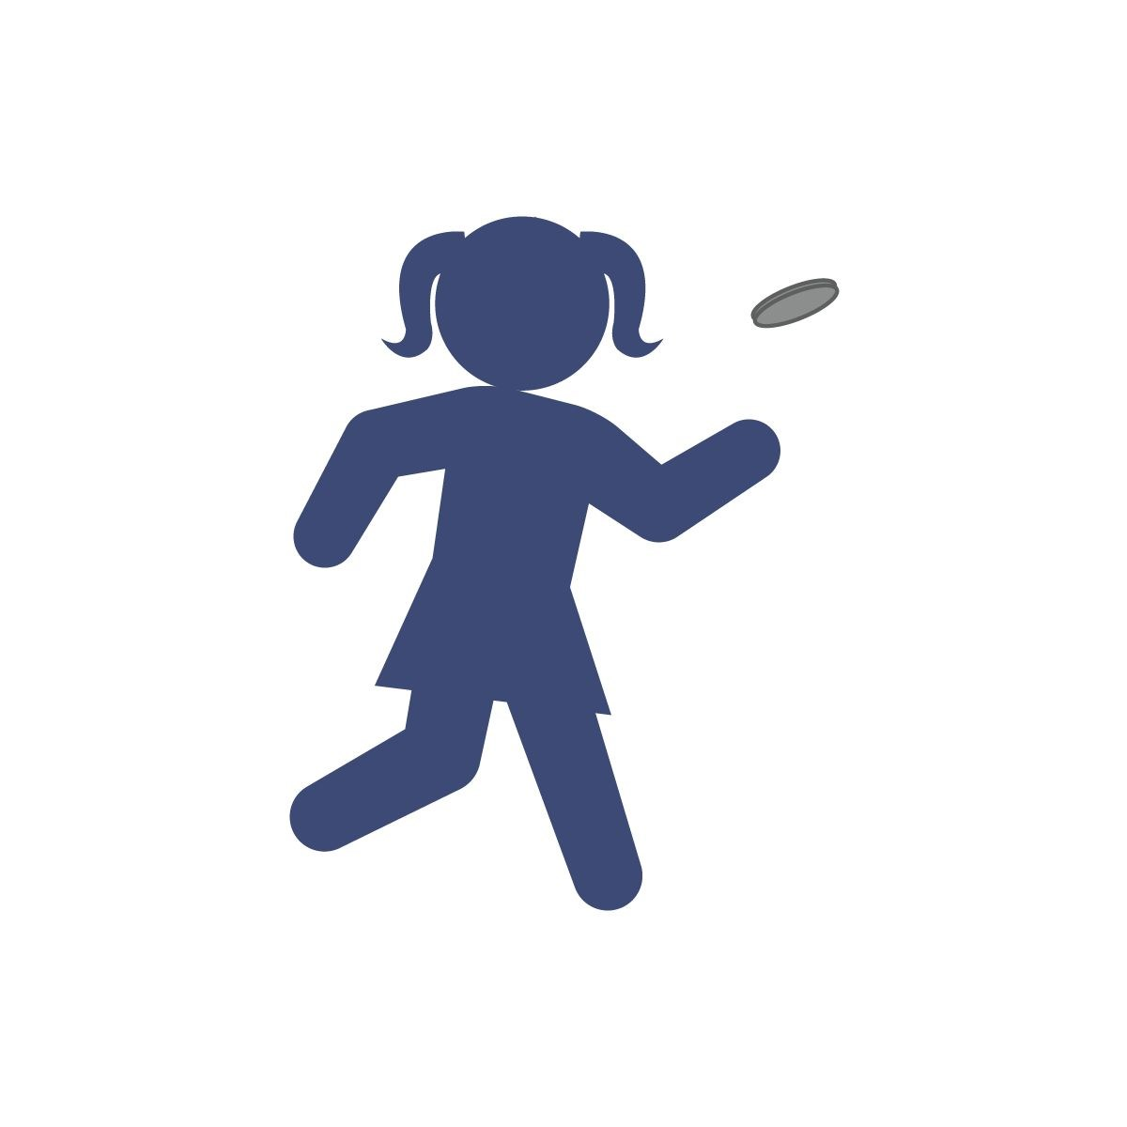
- This event is the Coin Flip 400-Meter Dash!
- The object is to run 400 running steps as fast as you can.
Remember, you’re running in place. Your feet move, but you stay in one spot.
- On the start signal, flip the coin. Let it land flat on the floor. If it lands on “heads” run 20 running steps and then flip the coin again.
- If the coin lands on “Tails” do not run. Flip again until it lands on heads.
- Count your steps out loud. When you get to 400, time stops, and the dash is over. ● Record your time on the official Field Day Score Card.

Get Ready: 1 Paper Plate (Piece of Cardboard or a School Folder)​ per Player, Center Line (2 Shoes or Cups will work) 1 Ping Pong Ball or a Balloon

Get Set: Create a center line on a table or the floor. Place the​ balloon or ball on the center line. Both players across from each other with the centerline in between them.

GO!
- This event is called Fan-a-War.
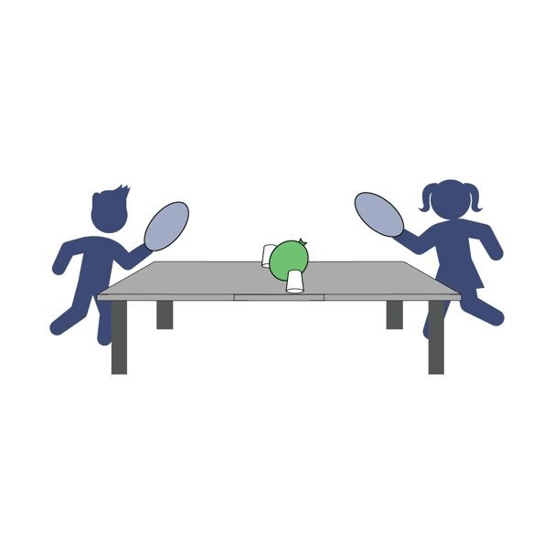
- The object of this game is to keep the ball on the opponent's side of the center line. You will have 1 minute.
- On the start signal, begin fanning the ball toward your opponent’s side of the center line and away from your side.
- If ball fall off back of table on opponent side, you get a point. Play to 11.
- Play and score 3 rounds and then write your score down on the official Field Day Score Card.

Get Ready: 10 Clothing Items from a Laundry Basket for Each​ Player

Get Set: Place 10 items from your laundry basket in a pile next to​ you.

GO!
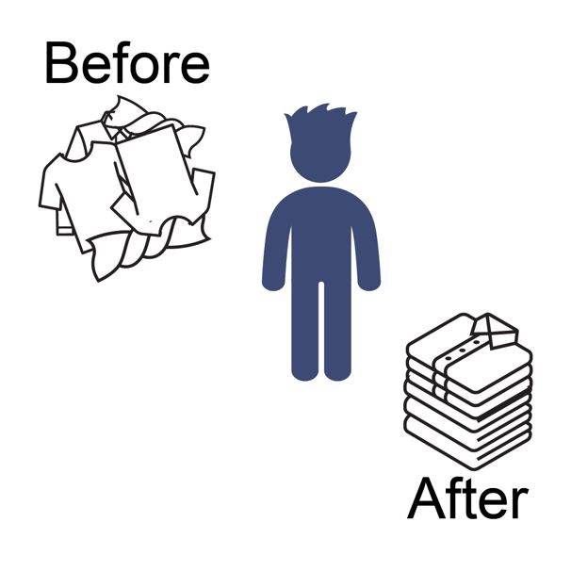
- This event is called Fast Folder.
- The object of this game is to score points by folding each item (shirt, pants, shorts, etc.). You have 1 minute to fold as many as possible.
- On the start signal, begin folding each piece of laundry.
- Score 1 point for each piece of laundry folded in one minute.
● Write your score down on the official Field Day Score Card.

Get Ready: Kitchen Spatula, 1 Tupperware/Plastic Lid​

Get Set: Place the lid facing up on a table or floor. Get your spatula​ ready for some lid flipping!

GO!
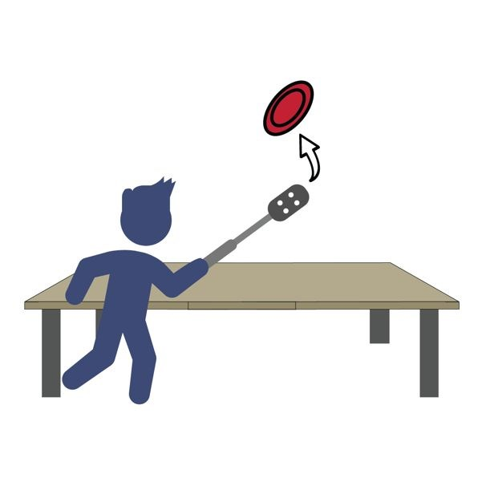
- This event is called Flip Your Lid.
- The object of this game is to flip your Tupperware lid upside down to earn points.
- Place the lid facing up on the table or floor, then slide the spatula under and flip the lid in the air. Let it land flat on the table or floor.
- Score a point for every lid that you flip upside down (0 points if it lands right-side up).
- Quickly reset the lid each time you flip it.
- You will have 1 minute to see how many times you can flip the lid upside down.
- Write your score down on the official Field Day Score Card.

Get Ready: 1–3 Balloons Per Player – Blow Them Up​

Get Set: Clear a 10’ indoor or outdoor space. Start with 1, 2 or 3​ balloons.

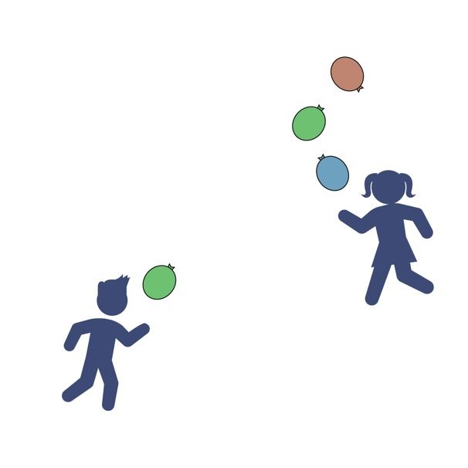
GO!
- This is Keep It Up. The object is to strike the ball(s) up using your hands as many times as you can in 1 minute.
- Don’t let it (them) hit the floor.
- On the start signal, strike the balloon(s) upward with your hands and count how many hits you can score in 1-minute.
- If using multiple balloons, alternate striking each balloon. Don’t strike the same balloon twice.
- If the balloon hits the floor, pick it back up and continue.
- On the stop signal, record your score on the official Field Day Score Card

Get Ready: 5-10 Shoes per Player, 1 Spot Marker per Player to​
Create Home Base for Each Player (paper plate, cups, sock etc.)

Get Set: Place shoes in a pile in the center of the room. Place​ Home Base spots 6’-10’ from the pile and 6’ apart from other players.

GO!
- This event is called Tennis Shoe Tower.
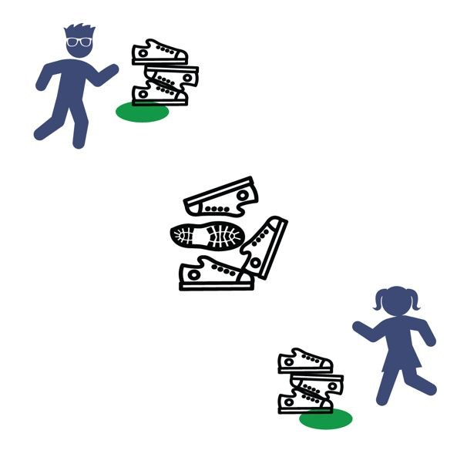
- The object is to build a shoe tower with shoes collected from the pile.
- On the start signal, players will run and take 1 shoe from the pile, return it to their home base and place it on their shoe tower.
- Repeat till all the shoes are gone.
(Run – Grab – Stack – Repeat!) ● If the tower falls, that's okay. Continue stacking to rebuild and continue.
- On the stop signal, count and score 1 point for each shoe in the tower.
- Write your score down on the official Field Day Score Card.

Get Ready: You’ll need 3 paper sheets per player, a bucket or​ laundry basket.

Get Set: Create 3 paper airplanes using a design of your choice.​ Place your bucket 5-10 feet away from your throwing line.

GO!
- This event is called Paper Plane Corn Hole.
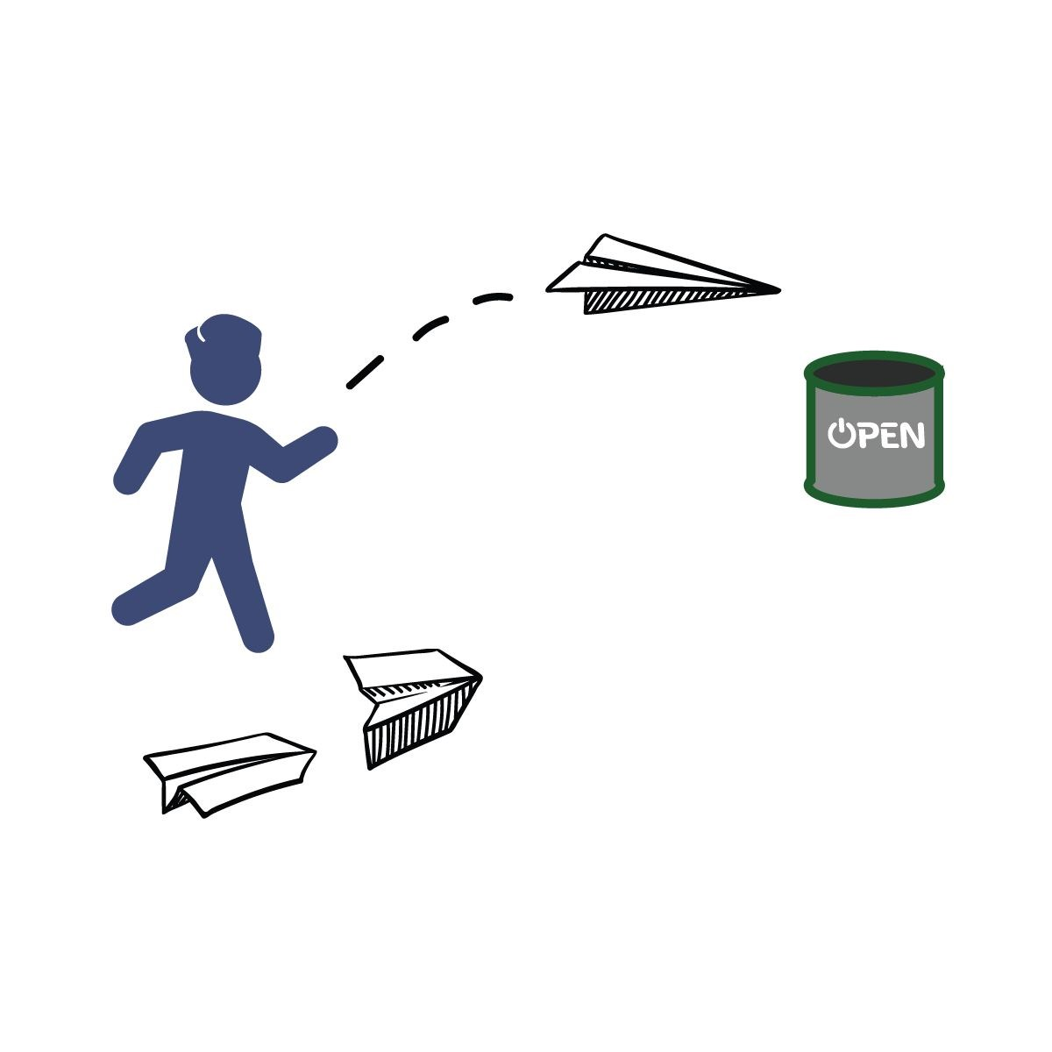
- The object of the game is to score points by throwing your paper airplane into your bucket. You have 1 minute to score as many as possible.
- Design and create 3 paper airplanes.
- On the start signal, fly your airplanes as many times as you can toward your bucket.
- Score 1 point for every plane that hits the outside of the bucket and 2 points for every plane that lands in the bucket.
- Write your score down on the official Field Day Score Card.

Get Ready:1 Balloon (or Paper Plate), 10 Plastic Cups​

Get Set: Set 10 empty plastic cups at the edge of a table in single​ file along the edge.

GO!
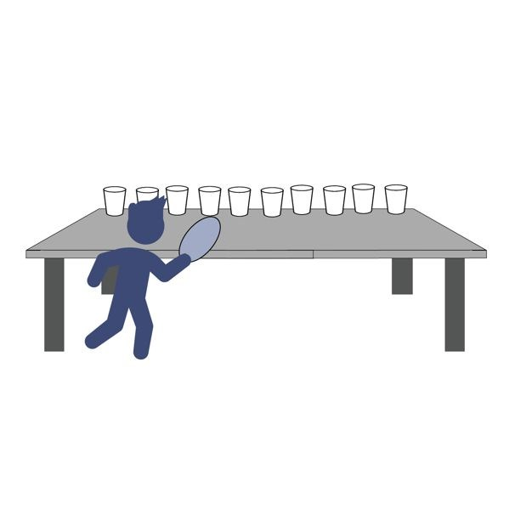
- This event is called Wind Bowling. The object of the game is to knock all the cups off a table edge using only the air from the balloon or paper-plate fan.
- You’ll do that by blowing the balloon up and aiming the escaping air towards the empty plastic cups. If you don’t have a balloon you can wave the paper plate like a fan with the fan’s air hitting the cups.
- Score a point for every cup that gets knocked off the table.
- You have 1 minute to knock down as many cups as you can.
- Write your score down on the official Field Day Score Card.

Get Ready: 10 sock balls, 1 Laundry Basket, 1 Bucket, 1​
Tupperware container

Get Set: Roll up the socks to make sock-balls. Stack the targets​ into skee-ball formation with the Tupperware inside the bucket and the bucket inside the laundry basket.

GO!
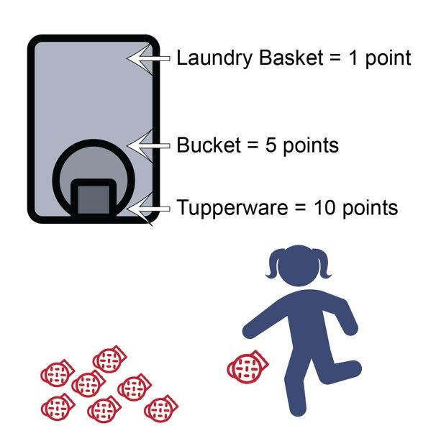
- This event is called Sock-er Skee-ball. The object of this game is to score points by kicking the sock ball into the skee-ball targets.
- You’ll do that by using your feet to kick the sock ball into the target.
- Score 1 point for every sock ball that lands in the laundry basket.
- Score 5 points for sock balls in the bucket.
- Score 10 points for sock balls in the Tupperware container.
- You get 10 chances to score as many points as you can.
- Write your score down on the official Field Day Score Card.

Get Ready: Two 1-Gallon Milk Jugs, Items to Mark Start/End points (cones, socks, plastic cups, etc.), Clock or Stopwatch

Get Set: Set up an area to move in by making a starting point and​ ending point. Distance can be 15 to 30 walking steps from beginning to end. Fill two used 1-gallon milk jugs with water (¼, ½, or full) and place at a start spot.

GO!
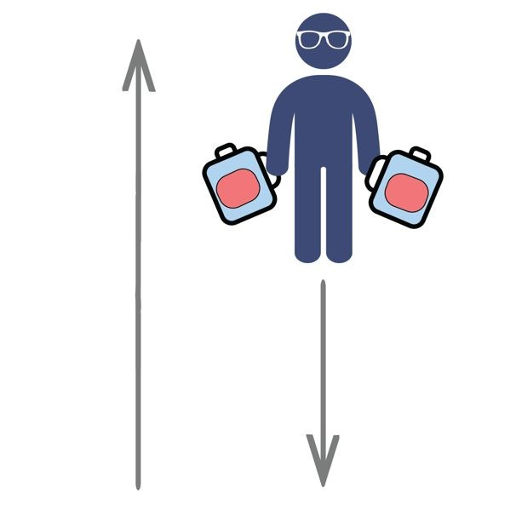
- This event is called the Milk Jug Relay. The object of this game is to carry the milk jug across the room as many times as you can.
- You get 1 point for each full length you travel.
- Add extra challenge by carrying two milk jugs at once.
- You have 1 minute to complete the challenge.
- Write your score down on the official Field Day Score Card.

Get Ready: 6 Bowls, 1 Sock Ball, Paper & Pencil to Tally Score​

Get Set: Set the bowls on the floor in a triangle pattern 3-4 inches​ apart. Put a piece of paper with the point total in the bottom of each bowl. Mark a throwing line 6-8 ft. away.
Hint: Big bowls are easier than small bowls!

GO!
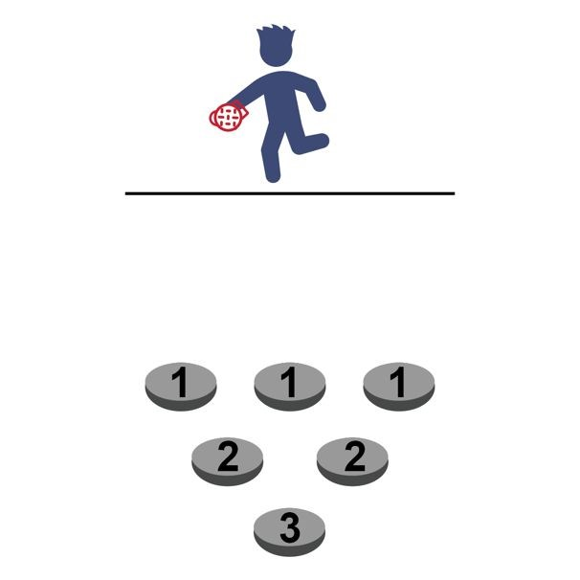
- The object of the game is to see how many points you can score in 1-minute.
- You do this by tossing the sock ball into the bowls and scoring points based upon where they land.
- After each throw, retrieve the sock ball and hustle back and throw again.
- If the sock lands in a bowl, use the pencil and paper to tally the points for that bowl.
- After 1-minute, calculate your tally and write your total number of points on the official Field Day Score Card.

Get Ready: 1 Empty Water Bottle, 1 Laundry Basket, 1​ Sock/Tennis Ball

Get Set: Lean the edge of the laundry basket on top of the empty​ water bottle. Designate a rolling line 8-10 ft. away (the open side of the laundry basket should be facing you).

GO!
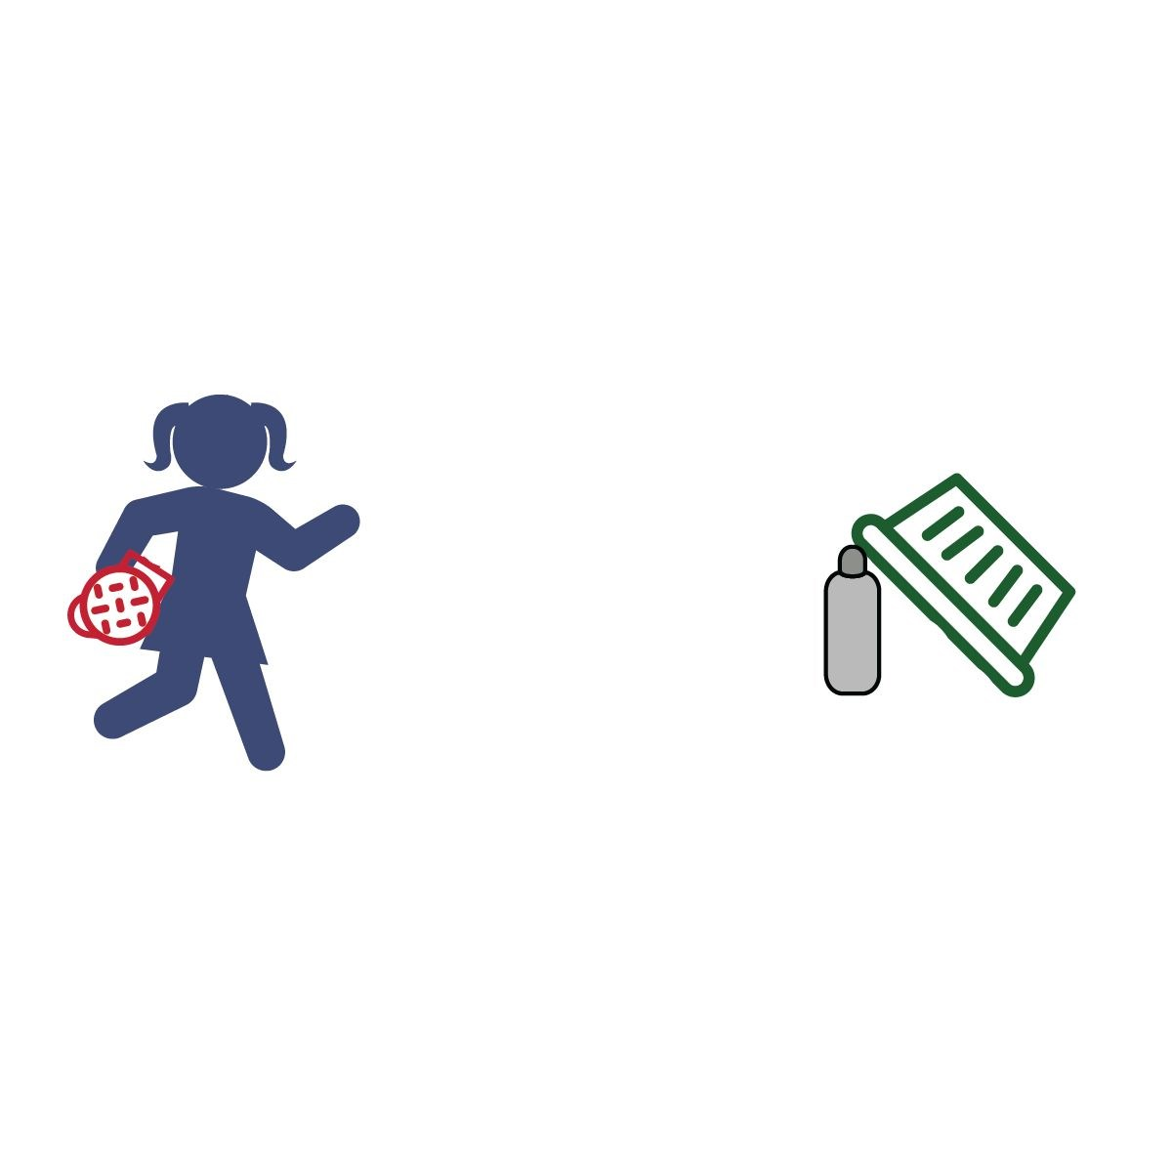
- The objective is to see how many points you can score in 1-minute.
- Do this by rolling the sock/tennis ball at the water bottle.
- To score the ball must hit the water bottle first (the roll does not count if it misses the bottle and knocks over the basket – sorry!).
- Rolls that hit the water bottle first score as follows:
  - point = basket falls and traps ball only
  - points = basket falls and traps water bottle only
  - points = basket falls and traps both ball and water bottle
- Write your total number of points on the official Field Day Score Card.

Get Ready: 1 Sock or Tennis Ball and 2 Plastic Cups per Person​
Get Set: Set the plastic ups 15-20 ft. from each other.​ GO!
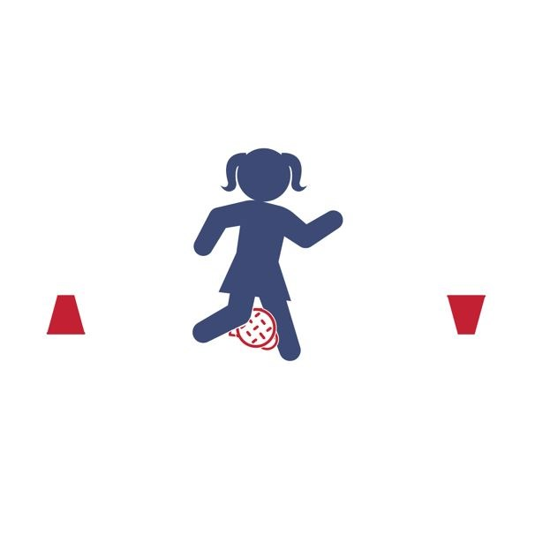
- You are a Penguin – the ball is an egg.
- There are 2 different ways to play:
(1) By Yourself or (2) Race A Partner.
- By Yourself Challenge​ – How many points you can score in 1-minute?
  - Place the egg between your knees and waddle back and forth from one cup to the other. When you reach the cup, turn it over.
  - If you drop the egg, do 5 jumping jacks before you continue.
  - Score 1 point for each cup you turn over.
- Race A Partner Challenge​ – Be the first Penguin to turn over 6 cups!
  - On the start signal, waddle to the first cup and turn it over.
  - Now hustle back to the other cup (as much as one can hustle while waddling). Continue back and forth.
  - If you drop the egg, do 5 jumping before you continue.
  - First to turn over 6 cups wins the race (scores 6 points).

Get Ready: 6’ Ladder, 6-12 Sock Balls, Laundry Basket, Empty​ Water Bottle

Get Set: Set up the ladder. Place the water bottle on the floor​ under the first rung. Mark a throwing line 10-15 ft. away. Place the laundry basket on the throwing line. Put all the sock balls inside the basket.

GO!
- “Climb the ladder” using the fewest throws.
- Start with the bottle on the floor under the first rung.
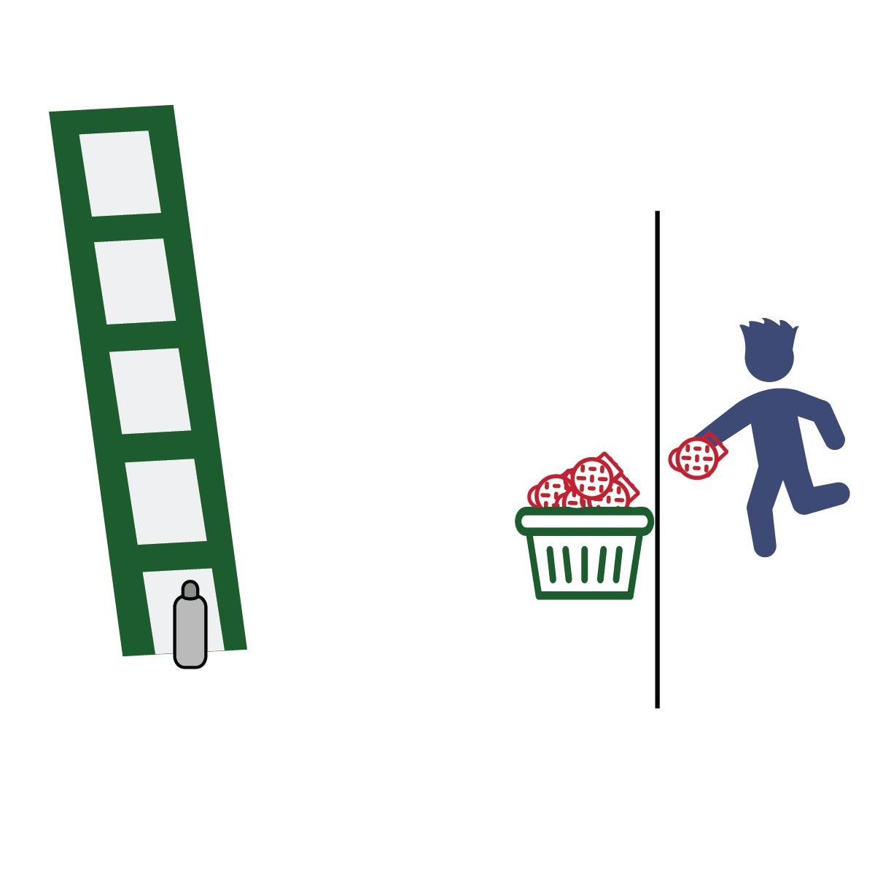
- Throw sock balls at the bottle until you knock it over. Take your time, this is not a race.
- Move the bottle up one rung each time you knock it off the ladder.
- If you run out of sock balls, collect them and continue.
- Count all of your throws on every step of the ladder. How many throws does it take to knock
the bottle off of the top rung of the ladder?
- Write the total throws on the official Field Day Score Card.

Get Ready: 1 Tennis Shoe, Spacious Area, Clean Feet​

Get Set: Make sure you have plenty of unobstructed space around​ you.

GO!
- How many points can you score in 1-minute?
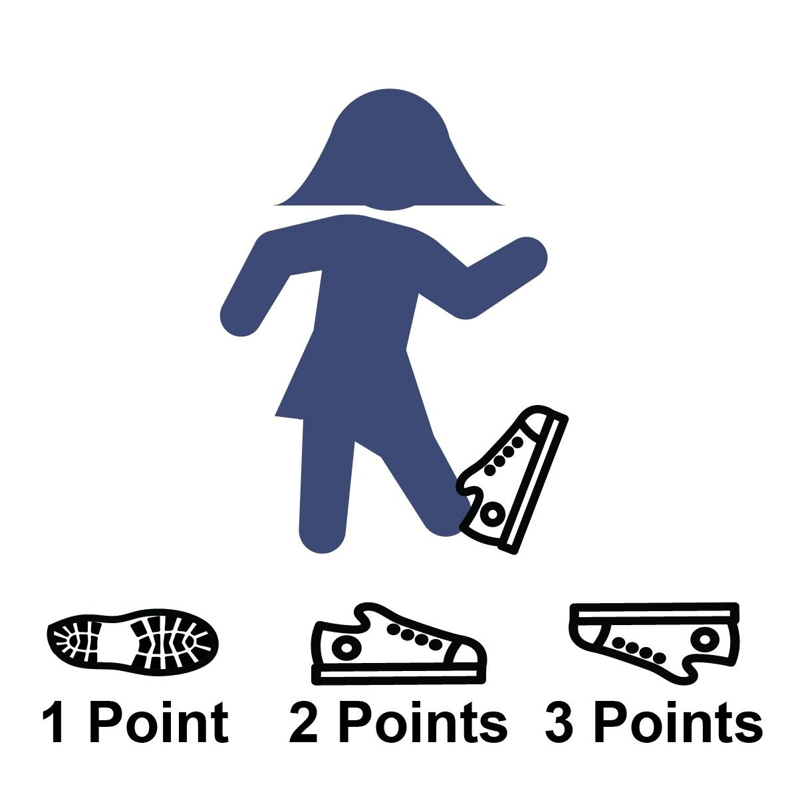
- Put your foot partially into the tennis shoe.
- On the start signal, flip the shoe into the air.
- Score as follows:
  - point = shoe lands on its side
  - points = shoe lands right side up
(sole of the shoe on the ground) 3 points = shoe lands perfectly​ upside down (no sides touching the ground)
0 points = if the shoe hits you in the head or knocks over a lamp.
- Write your total number of points on the official Field Day Score Card.
- Go wash your foot.

Get Ready: 1 spoon, 1 object to balance (small ball, marble, small​
toy), Items to Mark Start/Checkpoints (cones, socks, plastic cups, etc.), Clock or Stopwatch

Get Set: Set a starting point and a checkpoint. Distance can be 15​ to 30 walking steps from beginning to end. At the start point, get ready by placing the object on the spoon and balance it.

GO!
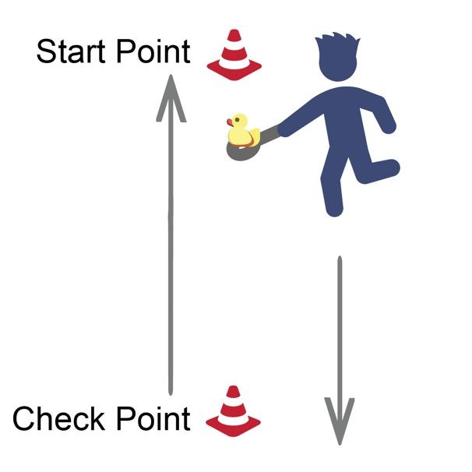
- This is the Spoon Relay. You have 1 minute to Score points by completing laps with an object balanced on a spoon.
- On the start signal, move carefully from the starting point to the checkpoint and back again (1 lap).
- Complete as many laps as possible without a drop.
- If you drop the object, stop walking, place it on the spoon, and begin again.
- Score 1 point for each lap completed without a drop.
- Write your score down on the official Field Day Score Card

Get Ready: Oversized Tee Shirt, Oversized Shorts, and a Hat;​
Items to Mark Start/Checkpoints (cones, socks, plastic cups, etc.);
Clock or Stopwatch

Get Set: Set up an area to move in by making a starting point and​ a checkpoint. Distance can be 15 to 30 walking steps from point to point. Put the shirt and hat on the check point opposite from the start point, put the shorts on the start point.

GO!
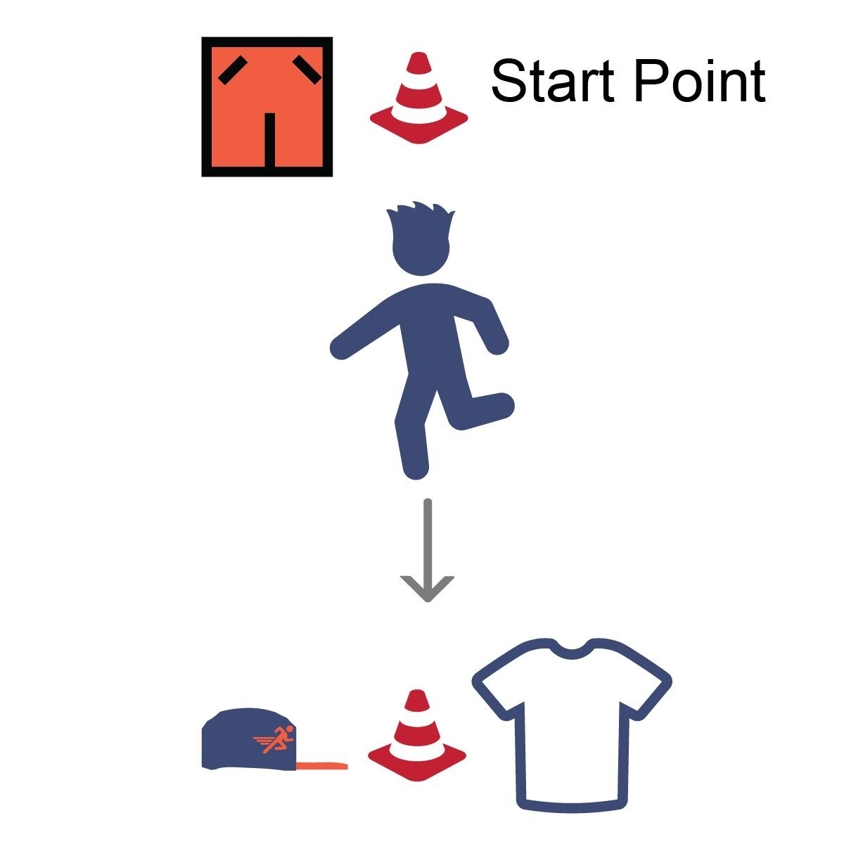
- This event is called the Clothes Relay. The object of this game is to see how fast you can go from point to point putting on the clothes and then finishing at the starting point.
- On the start signal, jog down to the checkpoint and put on the t-shirt, then jog back to the start point and put on the shorts, then jog back to the checkpoint and put on the hat, then jog back to finish at the start point.
- Start the Clock on “Go” and stop when you cross the finish with all the clothes on.

