Naviance Curriculum
Accessing Curriculum
- Navigate to https://student.naviance.com/chesapeake
- Click Student
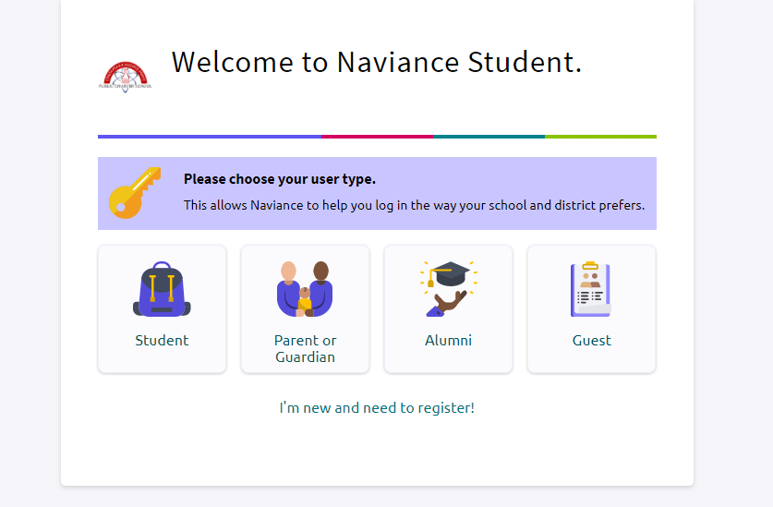
- Enter your username in the Email or username textbox.
- Enter your password and click continue.
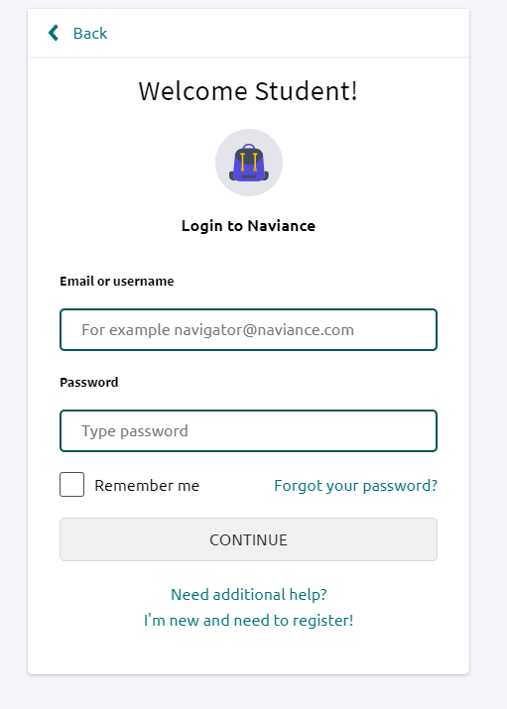

- Scroll down to the bottom of the page and under Resources to get ready click on Naviance College, Career and Life Readiness Curriculum
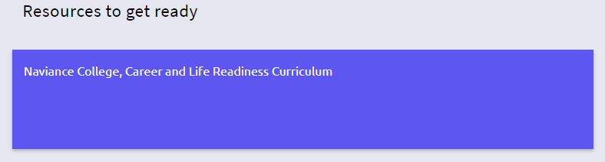
- Now you are ready to start your lessons within Naviance Curriculum
