

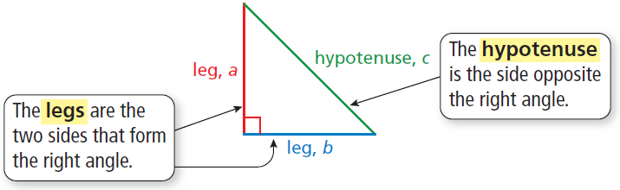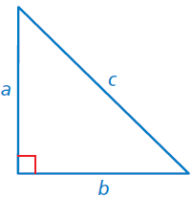

**Sides of a Right Triangle**

The sides of a right triangle have special names.

**Key Terms**

A ***square root*** of a number is a number that, when multiplied by itself, equals the given number.

A ***perfect square*** is a number with integers as its square roots.

The symbol is called a ***radical sign***. It is used to represent a square root.

The number under the radical sign is called the ***radicand***.

A ***cube root*** of a number is a number that, when multiplied by itself, and then multiplied by itself again, equals the given number.

A ***perfect cube*** is a number that can be written as the cube of an integer.

In mathematics, a rule is called a ***theorem***.

An ***irrational number*** cannot be written as the ratio of two integers.

Rational numbers and irrational numbers together form the set of ***real numbers***.

**Students will…**

Find square roots of perfect squares.

Evaluate expressions involving square roots.

Use square roots to solve equations.

Find cube roots of perfect cubes.

Evaluate expressions involving cube roots.

Use cube roots to solve equations.

Provide geometric proof of the Pythagorean Theorem.

Use the Pythagorean Theorem to find missing side lengths of right triangles.

Define irrational numbers.

Approximate square roots.

Approximate values of expressions involving irrational numbers.

Write a repeating decimal as a fraction.

Use the converse of the Pythagorean Theorem to identify right triangles.

Use the Pythagorean Theorem to find distances in a coordinate plane.

Solve real-life

problems.

**The Pythagorean Theorem**

* In any right triangle, the sum of the squares of the lengths of the legs is equal to the square of the length of

the hypotenuse.

*a* 2 + *b* 2 = *c* 2

**Converse of the**

**Pythagorean Theorem**

* If the equation *a* 2 + *b* 2 = *c* 2

is true for the side lengths of a triangle,

then the triangle is a right triangle.

**Standards**

**Common Core:**

**8.NS.1:** Know that numbers that are not rational are called irrational. Understand informally that every number has a decimal expansion; for rational numbers show that the decimal expansion repeats eventually, and convert a decimal expansion which repeats eventually into a rational number.

**8.NS.2:** Use rational approximations of irrational numbers to compare the size of irrational numbers, locate them approximately on a number line diagram, and estimate the value of expressions (e.g., π2).

**8.EE.2:** Use square root and cube root symbols to represent solutions to equations of the form *x*2 = *p* and *x*3 = p, where *p* is a positive rational number. Evaluate square roots of small perfect squares and cube roots of small perfect cubes. Know that $\sqrt{2}$ is irrational.

**8.G.6:** Explain a proof of the Pythagorean Theorem and its converse.

**8.G.7:** Apply the Pythagorean Theorem to determine unknown side lengths in right triangles in real-world and mathematical problems in two and three dimensions.

**8.G.8:** Apply the Pythagorean Theorem to find the distance between two points in a coordinate system.

**Chapter 7: Real Numbers and the Pythagorean Theorem**

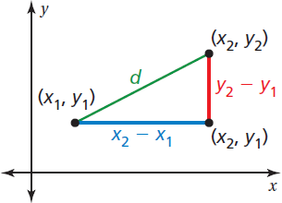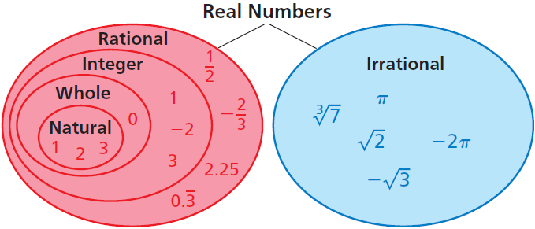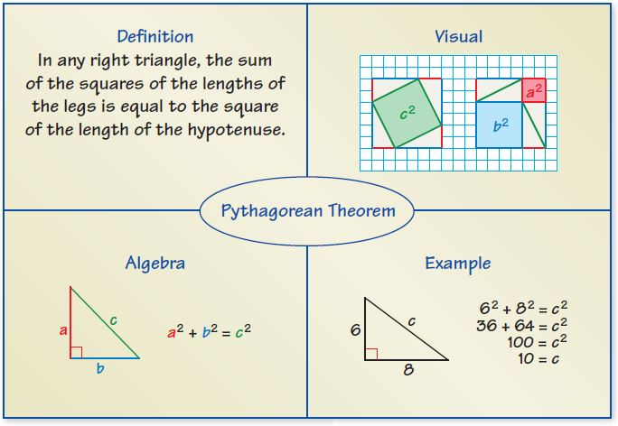

* The decimal form of an irrational number neither terminates nor repeats.
* A *subset* is a set in which every element is contained within a larger set.
* The sets of rational numbers and irrational numbers are subsets of the set of real numbers.
* The sets of natural numbers, whole numbers, and integers are subsets of the set of rational numbers.
* The *converse* of a statement switches the hypothesis and the conclusion.
* Squaring a positive number and finding a square root are inverse operations.
* The cube root of a perfect cube is an integer and can be evaluated as part of an expression.
* The Pythagorean Theorem is only true for right triangles.
* The square root of any whole number that is not a perfect square is irrational. The cube root of any integer that is not a perfect cube is irrational.

**Quick Review**

**What’s the Point?**

The ability to use the Pythagorean Theorem is very useful in real life when trying to decide what size of TV to

buy. Companies size their TV’s by the diagonal length of the screen. Have your students measure the length

and width of a space for a TV. What size TV would fit?

The STEM Videos available online show ways to use mathematics in real-life situations.

The Chapter 7: Metronome Design STEM Video is available online at www.bigideasmath.com.

A **Four Square** can be used to organize information about a topic. Write the topic in the “bubble” in the middle of the four square. Then write concepts related to the topic in the four squares surrounding the bubble. Any concept related to the topic can be used. Place four squares on note cards to use as a quick study reference.

**Essential Questions**

How can you find the dimensions of a square or a circle when you are given its area?

How is the cube root of a number different from the square root of a number?

How are the lengths of the sides of a right triangle related?

How can you find decimal approximations of square roots that are not rational?

In what other ways can you use the Pythagorean Theorem?

**Distance Formula**

The distance *d* between any two points (*x*1, *y*1) and (*x*2, *y*2) is given by the formula $d= \sqrt{{(x_{2}- x_{1})}^{2}+ {(y_{2}- y_{1})}^{2}}$.

**Writing a Repeating Decimal as a Fraction**

Let a variable *x* equal the repeating decimal *d*.

**Step 1:** Write the equation *x* = *d*.

**Step 2:** Multiply each side of the equation by 10

to form a new equation, where *n* is the

number of repeating digits.

**Step 3:** Subtract the original equation from the

new equation.

**Step 4:** Solve for *x*.

**Reference Tools**