Homecoming Countdown Spirit Week

(October 22- October 26)

* **Follow the School dress code as you dress down for Spirit Week PLZZZZZZZ** 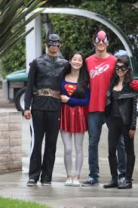

Monday (October 22)- Hero VS. Villain

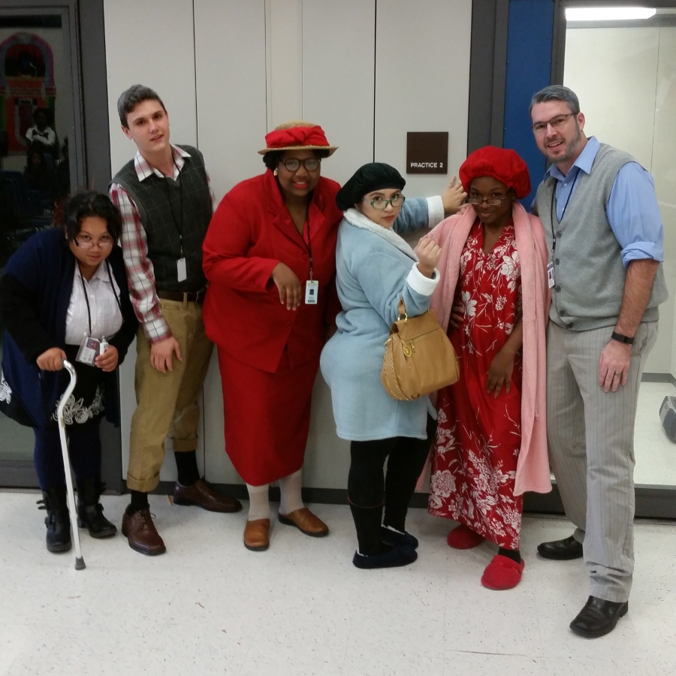

Tuesday (October 23)- Senior Citizens Day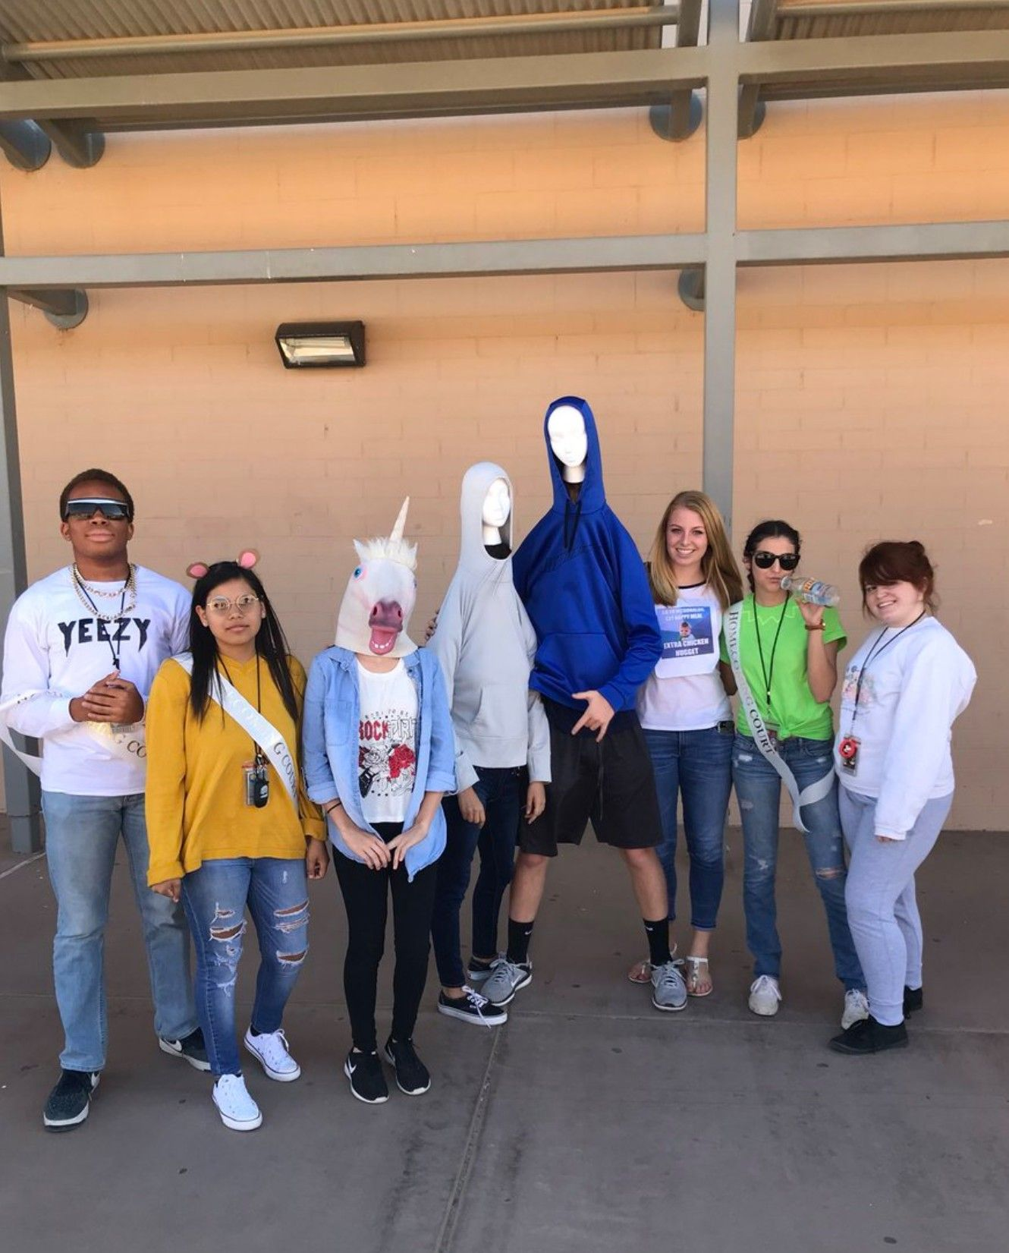

Wednesday (October 24)- **VINE** & Meme Day



Thursday (October 25)- Class Color Day

(9th grade- Green)

(10th grade- Red )

(11th grade- Blue )

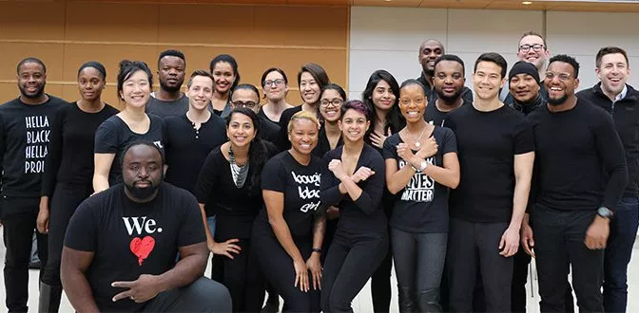

Friday (October 26)-

BLACKOUT DAY

**\*With Accent of Class Color\***