**8th Grade Service Project**

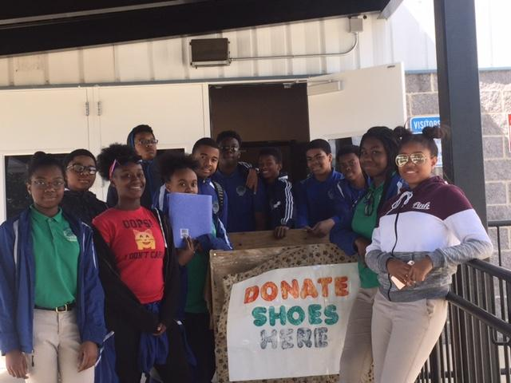

**323 pair of Shoes Collected!!**

The 8th Grade Service Project was a rewarding experience for both students and the Soles 4 Souls organization. We collected 323 pairs of shoes which surpassed our original goal of 300 pairs of shoes.

Service hours were earned by each 8th graders who volunteered to participate in this effort: Isaiah Gallaway, Lauryn Awkward, Kamara Manzie, Zorah Neal, Amiya Spencer, Marques Claiborne, Jaihem, Khalil Manzie, Zion Tyson, Clinton Wiggins, Malcolm Doster, and Ashley Brown. Please refer to Ms. Warehime to complete process for service hour submission.

Special shout out for Mr. Gallaway and Isaiah Gallaway for building the shoe collection box.

Last but not least, special thanks to the parents, CMIT South Staff, and the 8th Grade Promotion Committee who contributed to this effort.