Table Tennis Club 2016-17
Memorandum of Agreement
When: Club will meet Thursdays from 3:05 until 4pm.
Where: Mr. Vernor’s room (169) and the cafeteria
Why: Enjoy learning and practicing one of the the most widely played sports in the world (based on numbers of players). We will cover basic techniques, fundamental rules, as well as more advanced strategies.
I, the undersigned, comprehend the structures and intent of the Table Tennis Club. I also understand that pick up time is 4pm.
WITHOUT RETURNING THIS SIGNED FORM TO MR. VERNOR, I UNDERSTAND THAT I CANNOT PARTICIPATE IN THE THURSDAY AFTERNOON TABLE TENNIS CLUB ACTIVITIES.

Student name: __________________________ Signature_________________________

Parent name:___________________________ Signature__________________________
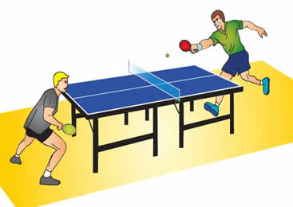
CONTACT MR. VERNOR: avernor@cmitacademy.org or call the front desk 301-350-6051, Thanks!

