Internship Opportunities (Please Start Applying NOW)

Browse through the opportunities below to discover exciting programs available to high school students. These opportunities are in addition to the ones found on the AACPS Internship Portal. They are highly competitive and have their own application process and deadline. Clink on the link below the logo to learn more about each opportunity. Read all of the requirements carefully before applying.

- https://www.thestemnet.com/resource/stem-internships-and-summer-opportunities-high-school-students
(THIS IS A GREAT SITE FOR A VARIETY OF INTERNSHIP OPPORTUNITIES FOR STEM STUDENTS IN MARYLAND) ** Each one has their own application and deadline so be sure to read everything thoroughly.

- The Secret Service Student Volunteer Service Program is designed to provide students with an understanding of the nature and the structure of the U.S. Secret Service. The program provides unpaid, academic-related work assignments that allow students to explore career options while developing personal and professional skills. Participants must be currently enrolled in school and are expected to volunteer
https://www.secretservice.gov/join/diversity/students/

- https://commerce.knack.com/stemconnect
- (This site shows a variety of internship opportunities, scroll through to see which ones you are eligible for)

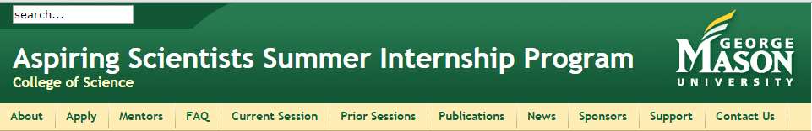
- http://assip.cos.gmu.edu/applications

https://www.nei.nih.gov/training/summer_intern

https://www.training.nih.gov/programs/sip
7.
http://www.niams.nih.gov/Research/Ongoing_Research/Branch_Lab/Career_Development_Outreach/summer.asp

8. NIH
  - http://www.niddk.nih.gov/research-funding/process/diversity/research%20and-training-for-students/short-term-research-experience-underrepresented-persons/Pages/default.aspx

9.
http://epa.gov/careers/internships/index.html
10.
http://www.hopkinsmedicine.org/neurology_neurosurgery/research/jhibs/
The Johns Hopkins High School Internship in Brain Science (JHIBS) is an 8-week summer program that provides high school junior and senior minority students with in-depth exposure to a research and clinical environment. Select students are nominated as interns for the Johns Hopkins Department of Neurology.
Please let your internship facilitator know if you are interested in being nominated

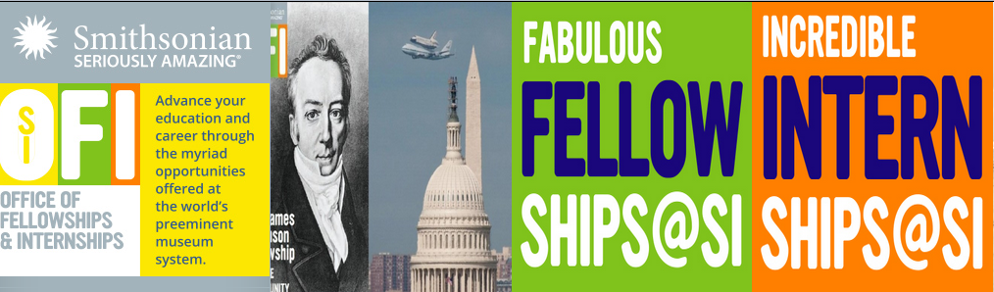
11.
https://naturalhistory.si.edu/education/youth-programs/yes-teen-internship-program
The Youth Engagement through Science (YES!) internship is a career immersion and science communication program for youth between the ages of 14-19, who are currently enrolled in high school (grades 9-11) in the Washington D.C. region. The YES! program, which runs from June-November, gives interns practical experience through a hands-on science internship with Smithsonian science staff. By participating in the program, teens will also have access to behind-the-scenes tours and field trips, creative studio workshops, college preparatory classes, and the opportunity to create their own TED-type talks.

12.U.S. Department of Education
The Department of Education (ED) offers internships for students interested in seeking valuable work experience in government and federal education policy and administration. Volunteers have the opportunity to make meaningful contributions to the Department's mission to promote student achievement and preparation for global competitiveness by fostering educational excellence and ensuring equal access.
ED offers internships in the fall, winter/spring, and summer. Typically interns are with the Department for eight to ten weeks (some can stay shorter or longer depending on circumstances). Read more details about application timelines.
http://www2.ed.gov/students/prep/job/intern/index.html

13. .Volunteer at the NOAA Office of National Marine Sanctuaries Headquarters in Silver Spring, Maryland

Eligibility
Volunteer internships are open to all individuals over the age of 15. The NOAA Office of Security requires a background check which will begin at the start of your volunteer experience.
http://www.noaa.gov/opportunities/student-opportunities

14. BANK OF AMERICA STUDENT LEADERSHIP INTERNSHIP
Every year, through our Student Leaders program we help connect 225 community-minded high school juniors and seniors to employment, skills development and service. They’re awarded paid summer internships with local nonprofits such as Habitat for Humanity and Boys and Girls Clubs of America and participate in a national leadership summit in Washington, D.C.
https://about.bankofamerica.com/en-us/what-guides-us/student-leaders.html#fbid=ITvCFl0Tqs8

15. Department of Education Internships
ED Student Volunteer Unpaid Internship Program
http://www2.ed.gov/print/students/prep/job/intern/index.htmlBeing The Department of Education (ED) offers internships for students interested in seeking valuable work experience in government and federal education policy and administration. Volunteers have the opportunity to make meaningful contributions to the Department's mission to promote student achievement and preparation for global competitiveness by fostering educational excellence and ensuring equal access.
ED offers internships in the fall, winter/spring, and summer. Typically interns are with the Department for eight to ten weeks (some can stay shorter or longer depending on circumstances).

16. MARYLAND ZOO
https://www.marylandzoo.org/volunteer/teen-volunteering/

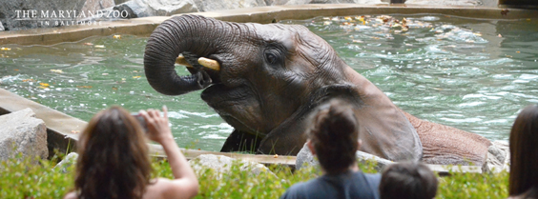
17. NIST (National Institute of Standards and Technology)-Summer Internships
The Summer High School Intern Program (SHIP) is a NIST-wide summer intern program for students who will have finished their junior or senior year of high school by the start of the program and are interested in scientific research only. All other high school applicants who do not want a summer research position should go to NIST Student Employment Programs for information on other NIST Programs. Students selected for this competitive volunteer program will participate in cutting-edge research at NIST, and will work closely with NIST staff scientists and engineers on a specific research problem
https://www.nist.gov/ohrm/summer-high-school-intern-program-application-process

The Ju18nior Volunteer Program is a multi-tiered service-learning program for teens with a strong interest in 18.18AAWDC YOUTH WORKS SUMMER INTERNSHIPS
18. This program provides Anne Arundel County's high school youth between the age of 16 and 21 with career exposure, employment preparation opportunities, and a meaningful paid, six week work experience. Participants work in a variety of entry-level jobs including summer camps, small businesses, healthcare settings, retail and hospitality, and nonprofits. http://aayouthworks.org/

19. The High School Research Apprenticeship Program (HSAP) is a summer STEM program open to high school students (Grades 11 – 12) who demonstrate an interest in STEM to work as an apprentice in an Army-funded university research laboratory. HSAP is designed so that students can apprentice in fields of their choice with experienced scientists and engineers full-time during the summer or part-time during the school year. Students receive an educational stipend equivalent to $10 per hour.
Students should visit the Army Educational Outreach Program site (AEOP) to find out more about HSAP, to locate a university and to apply:
HSAP: http://www.usaeop.com/programs/apprenticeships/hsap/

20. The Lost Towns Project, Inc. is partnered with Anne Arundel County’s Cultural Resources Division in executing an academic internship program for students of archaeology or historic preservation!

The Lost Towns Project, Inc., in cooperation with the Anne Arundel County Cultural Resources Division, has numerous volunteer opportunities year-round and welcomes newcomers of all levels of experience! Whether you want to assist in the field or in the lab, we have plenty of different experiences offered throughout the week.
For further information and to subscribe to our newsletter, contact our volunteer coordinator at volunteers@losttownsproject.org or subscribe here.
For information on academic internships, click here.

21. Maryland State Police Student Internship Program
This program is designed to meet both the academic and career objectives of students while providing useful administrative and operational support services to the Maryland State Police. The goals of the Student Intern Program are as follows:
- To provide students the opportunity to become familiar with police operations and better understand, through direct experience and training, the complexities of the criminal justice system.
- To foster students' interest in law enforcement careers.
- To assist students interested in pursuing a law enforcement career with the Maryland State Police or other law enforcement agencies prepare for the police officer application process.
- To enable high school, college and graduate school students to earn course credits and gain valuable career-related experience through meaningful and appropriate volunteer work.
- To offer high school students the opportunity to earn community service credits toward graduation.
To encourage and support a culture of community service among young people and build a foundation of commitment to volunteering.
http://mdsp.maryland.gov/Careers/Pages/Intern.aspx

22.

NASA Internships and Fellowships

https://intern.nasa.gov/

Description:
The GEMS Summer Program at the U.S. Army Research Laboratory, Adelphi Laboratory Center (ARL-ALC), provides middle school and high school students with the opportunity to explore new concepts and participate in hands-on lab experiments and activities related to Science, Technology, Engineering, and Mathematics (STEM) topics. Near-Peer Mentors (NPMs) work collaboratively with educators, scientists and engineers to provide instruction and engage students in inquiry-based, hands-on lab experiments and activities in support of ARL-ALC‘s current research initiatives. Program areas include: electronic devices, renewable energy, biotechnology, robotics, and computer science.

23. Lombardi Summer Research Program Georgetown University is designed for outstanding high school and undergraduate students interested in pursuing a career in bio-medically related sciences.
https://lombardi.georgetown.edu/Summer_Volunteer
The Lombardi Comprehensive Cancer Center offers the Summer Research Volunteer Program as an outreach initiative with the objective of attracting and training the next generation of scientists to take on the fight against cancer.

