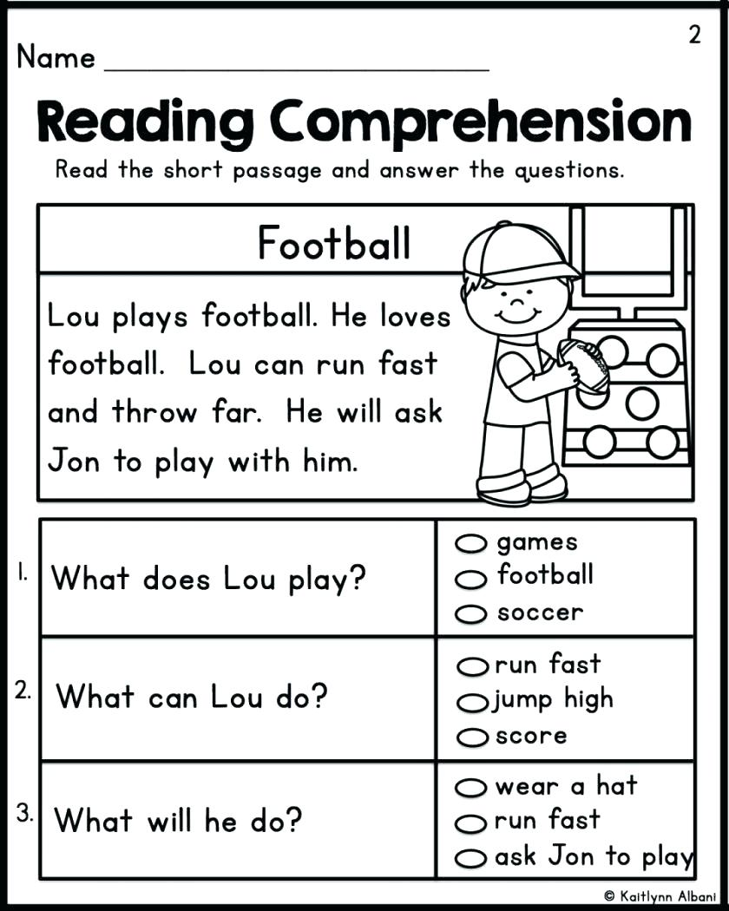

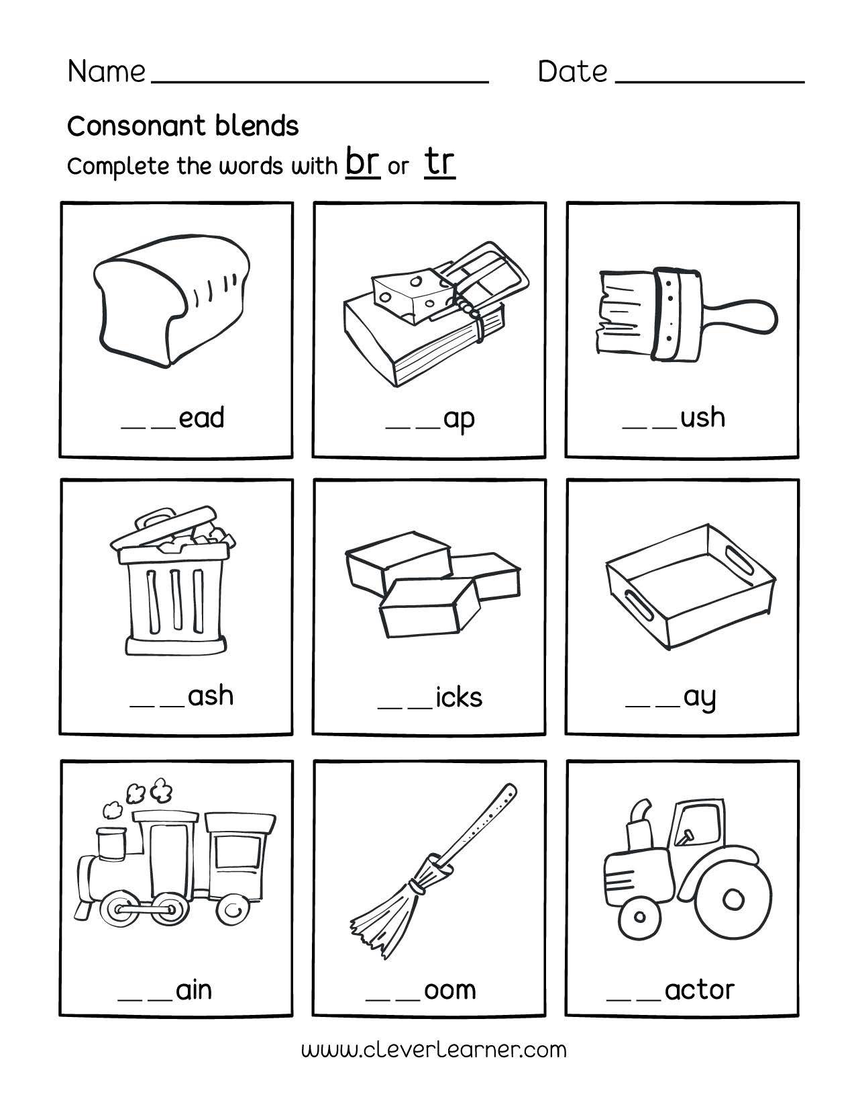

/Users/REBECCA.BARTON/Library/Containers/com.apple.mail/Data/Library/Mail Downloads/8476644E-0766-4625-8A8C-82CC826AC62F/Short Vowel Review.pdf

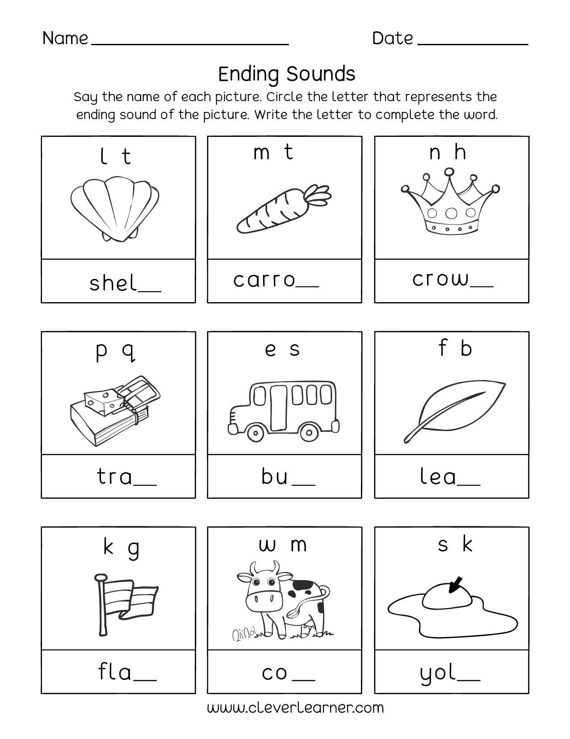

/Users/REBECCA.BARTON/Library/Containers/com.apple.mail/Data/Library/Mail Downloads/EB414ECB-E09B-4894-B5BE-B46DF1524F87/Re-write Sentences Worksheets.pdf